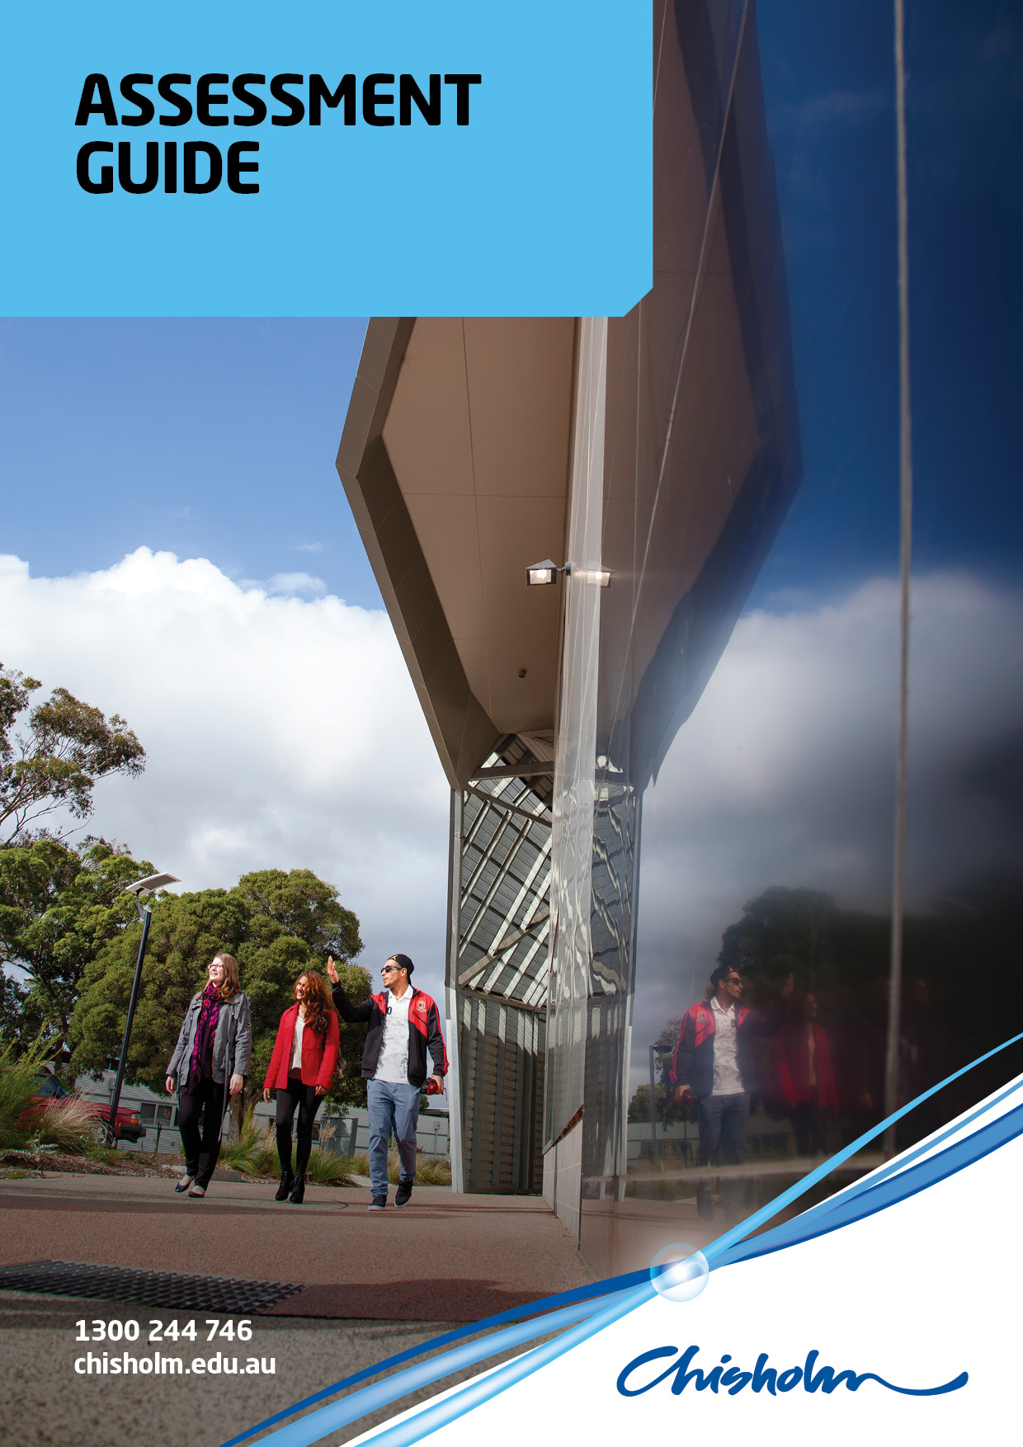
AHC51110 Diploma of Conservation and Land Management
AHCFAU501A Manage Fauna Populations

ASSESSMENTS
The following assessments will be used to collect evidence of the knowledge and skills you have gained from your Learning Program. You will be required to demonstrate your ability to perform to the standard required in the workplace, as specified within the assessment task criteria as detailed below:

Assessment Tasks | Week / Session / Block of Assessment
1 Desktop Survey – 20%
2 Vegetation and Fauna Surveys (Field Work) – 20%
3 Fauna Management Plan - 50%
4 Quiz – 10%
REQUIREMENTS
Please read the following instructions about your assessment. They will help you to achieve the level of performance required for a successful assessment.
To achieve competence in the unit/s a learner must meet requirements for all assessment tasks listed before the assessor can sign you as competent for the unit/s

If you are undertaking a Diploma course or higher you must first be assessed as competent in the unit/s. Only once you have achieved competence can the assessor award you a grade or mark against the entire unit/s.

Your assessor will provide feedback to you, both where competency has been demonstrated and where further evidence is required and allows you to understand why a result has been given.

It is important that you clearly understand all the requirements of assessment. If you have difficulty with the terms or the steps to follow please speak to your teacher / instructor prior to commencing.
RE-ASSESSMENT
If you do not achieve the required standard, you will be given the opportunity to be re-assessed by the assessor. Arrangements will be made on an individual basis.
ASSESSMENT APPEALS
A student who is dissatisfied with the outcome of his/her assessment review, in the first instance, discuss their concerns with the teacher and/or program coordinator. If the issue is not resolved, the student may appeal the decision(s) on one or both of the following grounds:
- that a procedural irregularity has occurred
- that evidence was inappropriately assessed
Appeals should be made in writing to the Teaching Area Manager of this course.

ASSESSMENT TASK #1
ASSESSMENT TASK TITLE: Desktop Survey
DUE DATE: 16 August 2016

Description of the assessment
Choose a local native fauna species relevant to your workplace and an area where this species occurs and can be managed. (For students undertaking this unit 2016 this unit will focus on the Black Wallaby (Wallabia bicolour) at the Royal Botanic Gardens Victoria, Cranbourne). Using a variety of tools (websites, data bases, publications, etc.) undertake a desktop survey of your chosen fauna species in general and in relation to the area you have chosen to study.
This survey should be presented as a fully referenced report and be presented in accordance with industry standards (see documents provided). The survey may include (but is not limited to) the following:
- Biology and ecology
- Distribution and populations
- Habitat requirements
- Conservation status
- Monitoring and assessment techniques
- Threats and impacts
- Management programs

Assessment method used:
This assignment will be assessessed against the following:
Criteria | High (3) | Medium (2) | Low (1) | No evidence (0)
Introduction | The introduction is engaging, states the main topic and previews the structure of the survey. | The introduction states the main topic and previews the structure of the survey. | The introduction states the main topic but does not adequately preview the structure of the survey. | There is no clear introduction or main topic and the structure of the survey is missing.
Structure | Writer denotes logical and subtle sequencing of ideas through well-developed paragraphs, transitions are used to enhance organisation. | Paragraph development present but not perfected. | Logical organisation; organisation of ideas not fully developed. | No evidence of structure or organisation.
Contents | All required information is discerned with clarity and precision and contains relevant up to date information. | Contains some information which may be discerned with clarity and precision and may contanin some relevant information. | Contains little information which may not discerned with clarity and precision and may contains little relevant up to date information | Information is not discerned with clarity and precision and contains no relevant or up to date information
Tables/Figures | Tables/figures are relevant, labelled appropriately and presented in a clear manner.  Tables/figures are referred to in the text. | Tables/figure are relevant, labelled appropriately and presented in a clear manner. | Tables/figures are labelled and presented in a clear manner. | Tables/figures are absent or unfocussed.
Nomenclature | No errors in scientific nomenclature. | Almost no errors in scientific nomenclature. | Many errors in scientific nomenclature. | Numerous and distracting errors in scientific nomenclature.
Referencing | All cited works both text and visual, are done in the correct format with few errors.  Bibliography is done in the correct format with few errors. | Some cited works, both text and visual, are done in the correct format. Inconsistencies evident.  Bibliography is done in the correct format. | Few cited works, both text and visual, are done in the correct format.  Bibliography is done in the correct format with some errors. | No cited works, text or visual. Bibliography absent

Marking Scheme:
Competency based ☐ Competent + grading/mark ☒
Assessment instruction
This assessment will be undertaken during class time and as homework.
Assessment evidence to be submitted
This assessment should be presented as a fully referenced report and be presented in accordance with industry standards (see documents provided). .
ASSESSMENT TASK #2
ASSESSMENT TASK TITLE: Vegetation and Fauna Survey
DUE DATE: Attendance at 2 Field Trips – 27/8/16 & 11/10/16

Description of the assessment
As a group you will be required to develop, undertake and analyse vegetation cover and abundance surveys and fauna transect surveys to:
- assess the Black Wallaby (Wallabia bicolour) population on site
- assess the impacts of the Black Wallaby (Wallabia bicolour) population on the environment.

Vegetation cover and abundance surveys will be conducted using a modified Domin scale and fauna transect and scat plot surveys will be conducted on site at the RBGVC. All surveys will be conducted on a number of occasions throughout the term in accordance with the details contained in the attached information.
Marking Scheme:
Competency based ☒ Competent + grading/mark ☐
.

ASSESSMENT TASK #3
ASSESSMENT TASK TITLE: Fauna Management Plan
DUE DATE: 22 November 2016

Description of the assessment
Based on your research and data collected during Assessment 1 Desktop Survey and Assessment 2 Vegetation and Fauna Surveys develop a Fauna Management Plan for the Black Wallaby (Wallabia bicolour) population at the Royal Botanic Gardens Victoria Cranbourne.
The Fauna Management Plan should be presented as a fully referenced Scientific Report and should be presented in accordance with industry standards (see documents from Arthur Rylah Institute provided).
The Fauna Management Plan may include (but is not limited to) the following:
- Summary
- Introduction
  - Species
  - Location
  - Why are we doing the survey?
- Aim
- Methods
  - Vegetation cover and abundance survey
  - Fauna transect and scat plot surveys
- Results
  - Vegetation
  - Fauna
  - Tables and graphs
- Discussion
  - Legislation
  - Permits
  - OH&S
  - Stakeholders
  - Management options
  - Costs benefit analysis
  - Monitoring plan
- Recommendations
- References

Assessment method used:
This assignment will be assess agains the following:
Criteria | High (3) | Medium (2) | Low (1) | No evidence (0)
Aim | Clearly and concisely states the plan’s aim in a single sentence. The aim has defined outcomes and is measureable. | States the plan’s aim in a single sentence. | Aim is incomplete and/or unfocussed. | Absent
Introduction | The introduction is engaging, states the main topic and previews the structure of the plan. | The introduction states the main topic and previews the structure of the paper. | The introduction states the main topic but does not adequately preview the structure of the paper. | There is no clear introduction or main topic and the structure of the plan is missing.
Structure | Writer denotes logical and subtle sequencing of ideas through well-developed paragraphs, transitions are used to enhance organisation. | Paragraph development present but not perfected. | Logical organisation; organisation of ideas not fully developed. | No evidence of structure or organisation.
Contents | All required information is discerned with clarity and precision and contains relevant information. | Contains some relevant information | Contains little relevant information | Contains no relevant
Conclusion | Complete and correct analysis and development of a recommendations. | Analysis and development of recommedntations. | Limited analysis and development of recommendations. | Incorrect analysis and development of recommendations.
Tables/Figures | Tables/figures are relevant, labelled appropriately and presented in a clear manner.  Tables/figures are referred to in the text. | Tables/figure are relevant, labelled appropriately and presented in a clear manner. | Tables/figures are labelled and presented in a clear manner. | Tables/figures are absent or unfocussed.
Nomenclature | No errors in scientific nomenclature. | Almost no errors in scientific nomenclature. | Many errors in scientific nomenclature. | Numerous and distracting errors in scientific nomenclature.
Referencing | All cited works both text and visual, are done in the correct format with few errors.  Bibliography is done in the correct format with few errors. | Some cited works, both text and visual, are done in the correct format. Inconsistencies evident.  Bibliography is done in the correct format. | Few cited works, both text and visual, are done in the correct format.  Bibliography is done in the correct format with some errors. | No cited works, text or visual. Bibliography absent
Marking Scheme:
Competency based ☐ Competent + grading/mark ☒
Assessment instruction
This assessment will be undertaken during class time and as homework.
Assessment evidence to be submitted
This assessment should be presented as a fully referenced report and be presented in accordance with industry standards (see documents provided).
ASSESSMENT TASK #4
ASSESSMENT TASK TITLE: Animal Ethics and Legislation Quiz
DUE DATE: 15 November 2016

Description of the assessment
This Quiz will be undertaken on Moodle.

Marking Scheme:
Competency based ☐ Competent + grading/mark ☒
Assessment instruction
Quiz will be undertaken on Moodle during class time.

BUSINESS AREA TO RETAIN A COPY

UNIT ASSESSMENT SUMMARY RESULT SHEET
BUSINESS AREA TO RETAIN A COPY
UNIT CODE/S – UNIT TITLE/S: | COURSE CODE AND TITLE:
STUDENT NAME: | STUDENT NUMBER:
ASSESSMENT TASK | MET REQUIREMENT | DATE ASSESSMENT TOOK PLACE
TASK # - Title | Yes / No
TASK # - Title | Yes / No
TASK # - Title | Yes / No
REASONABLE ADJUSTMENTS:
Is adjustment that may be made to an assessment process to cater for the needs of a student undertaking the assessment without compromise to the validity of the process or required competence criteria

Student has Met Requirements (MR) of all assessment tasks ☐
Student did not complete the Further Evidence Requirements (FER) ☐
COMPETENCE RESULT:
Competent ☐ Not Competent ☐
GRADE OUTCOME / MARK RANGE:
GP Pass ☐ G3 Credit ☐ G2 Distinction ☐ G1 High Distinction ☐
50-59% 60-69% 70-79% 80-100%

Additional comments: (if required)

DATE : | ASSESSOR  NAME: | ASSESSOR  SIGNATURE:

GRADING INFORMATION

IMPORTANT: a student must achieve Meets Requirements on all assessment tasks and be assessed as competent for the unit of competence before a grade / mark can be given for the unit.
 | GP – Pass 50/59% | G3 - Credit 60-69% | G2 – Distinction 70 – 79% | G1 – High Distinction 80 – 100%
 | COMPETENT PLUS  PASS  Provide a description of criteria needed to achieve Pass level above competence | COMPETENT PLUS CREDIT  Provide a description of criteria needed to achieve Credit level above competence | COMPETENT PLUS DISTINCTION  Provide a description of criteria needed to achieve Distinction level above competence | COMPETENT PLUS HIGH DISTINCTION  Provide a description of criteria needed to achieve High Distinction level above competence
Assessment Task 1 |  | .
Assessment Task 2
Assessment Task 3

