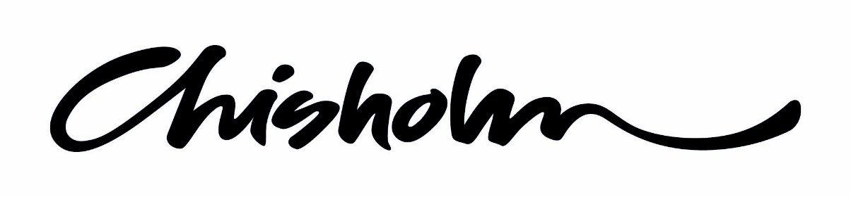

AHCILM302A Provide appropriate information on cultural knowledge

ASSESSMENT TASKS

Student Instructions
- Complete all tasks and activities using available class time, class notes and other resources.

- Work may be submitted in either hard or soft copy.

- Every assessment submitted requires a complete cover page noting the authenticity declaration, your student number and task name and number. Assessments may not be received without a complete cover page. If submitting via email you still require a cover page as first page of your assessment task.

- Work to the timelines set by your teacher. Late submission may result in loss of marks. Teachers may not remind you of due dates, you are responsible for submitting on time.

- Each assignment needs to be passed and will contribute to the overall assessment grade for this unit.

- Practical or observation based assessment tasks require your presence and participation; you are responsible for tracking your tasks and ensuring they are achieved.

AHCILM302A Provide appropriate information on cultural knowledge
ASSESSMENT TASKS
Name
Student ID No
Class Code
Telephone No
Assessment Task (Name & No. as per handout)
Facilitator Name
Due Date |  | Submitted Date
In submitting this assignment for assessment, the student acknowledges that:
- References are included, where applicable
- A backup copy of the assignment has been retained by the student
- The Chisholm Institute policy on plagiarism has not been breached
(that is, the contents of the assignment are all the work of the student, including in-class small group work and work in the student’s practice environment).
Department Use Only:
ASSESSMENT TASK DECISION
Comments:

Task Outcome: MR Meets Requirements
FER Further Evidence Required – resubmit by date: / /
UNIT Outcome: MR FER Further Tasks to Complete
Entering a grade and saving associated evidence in Chisholm Institute’s files provides verification by the assessor.
Assessor Name: _____________________________ Date:

ASSESSMENT TASKS
AHCILM302A Provide appropriate information on cultural knowledge
This unit covers the process of maintenance of cultural knowledge by indigenous people and if and how this knowledge may be provided to others and defines the standard required to: investigate cultural knowledge in accordance with cultural protocols; investigate relationships between land features, seasons and spirituality; identify plants, animals and resources used for medicine and food; provide information on cultural knowledge in accordance with cultural protocols.

- Project

Identify 10 plants, animals or resources used for medicine or food. Include as much detail as you can. Include photos, where it is found, how is it used and any relationship to seasons or spirituality. Include the indigenous name, common name and latin name.
For three of these, your most detailed, prepare and present a short Powerpoint.

- Questions
Students will complete written responses to the four activity questions

NAME:
Activity 1 :BRAINSTORM - What do you know about Aboriginal culture?

Activity 2: How do you find out who the traditional land owners are?

Aboriginal Australia

Activity 3 :Write about one of the numerous injustices committed against Aboriginal Australians. It may be something that has happened in the past or is still occurring. Include an account of the event/s and your thoughts about it.

Activity 4 : List and describe 4 protocols for culturally respectful engagement with Aboriginal and Torres Strait Islander people.

Protocol | Description | Significance or meaning

