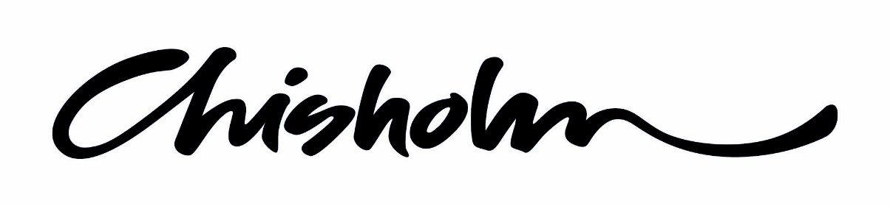

AHCNAR301A Contribute to OH&S

ASSESSMENT TASKS

Student Instructions
- Complete all tasks and activities using available class time, class notes and other resources.

- Work may be submitted in either hard or soft copy.

- Every assessment submitted requires a complete cover page noting the authenticity declaration, your student number and task name and number. Assessments may not be received without a complete cover page. If submitting via email you still require a cover page as first page of your assessment task.

- Work to the timelines set by your teacher. Late submission may result in loss of marks. Teachers may not remind you of due dates, you are responsible for submitting on time.

- Each assignment needs to be passed and will contribute to the overall assessment grade for this unit.

- Practical or observation based assessment tasks require your presence and participation; you are responsible for tracking your tasks and ensuring they are achieved.

AHCNAR301A Contribute to OH&S
ASSESSMENT TASKS
Name
Student ID No
Class Code
Telephone No
Assessment Task (Name & No. as per handout)
Facilitator Name
Due Date |  | Submitted Date
In submitting this assignment for assessment, the student acknowledges that:
- References are included, where applicable
- A backup copy of the assignment has been retained by the student
- The Chisholm Institute policy on plagiarism has not been breached
(that is, the contents of the assignment are all the work of the student, including in-class small group work and work in the student’s practice environment).
Department Use Only:
ASSESSMENT TASK DECISION
Comments:

Task Outcome: MR Meets Requirements
FER Further Evidence Required – resubmit by date: / /
UNIT Outcome: MR FER Further Tasks to Complete
Entering a grade and saving associated evidence in Chisholm Institute’s files provides verification by the assessor.
Assessor Name: _____________________________ Date:

AHCNAR301A Contribute to OH&S
ASSESSMENT TASKS

- Written Responses
Students are to complete written response to a number of questions and activities.

- Observation
Students will be observed to demonstrate their knowledge on a range of OH&S topics and issues.

- Safety TV
Watch a series of Safety videos and obtain at least 60% of the answers correct.
- Understanding Safety at Work
- Manual Handling
- Noise Hazards
- Hazardous Materials

ASSESSABLE TASK  OBSERVATION CHECKLIST | Student Name
- Identify hazards
In a variety of situation or scenarios identify all potential hazards. Some group brainstorm and discussion, report back to class.

- Reporting a hazard
Brainstorm and then discuss your experience with reporting a hazard. What’s good, bad or otherwise about this experience. What is the ideal procedure for reporting a hazard? Whole class discussion.
- Conduct a risk assessment – SWMS
Use SWMS & risk matrix to conduct a risk assessment of typical industry activities
- Workplace procedures are followed correctly
Discuss in small groups the different workplace tasks you have conducted and the instructions you were given. Were they adequate? Why, why not? Whole class discussion.
- Risks to others
In small groups think about and discuss times when you have recognised risks to other workers, people or animals and have taken action. What about emergencies?

- PPE
For a range of situations identify the PPE required. How is the PPE used, stored and maintained correctly?
- Pre-start Checks
Conduct some pre-start checks on various equipment. What are we looking for? How can this be documented?

- Hazardous Substances
Identify risks, assess risks and manage risks when working with hazardous substances

- Manual Handling
Demonstrate correct manual handling techniques.
- Reporting
Discuss all the ways that OH&S issues can be reported, which are effective and which arnt? Discuss the importance of incident reports and complete one?

CERT III: Contribute to OH&S

STUDENT ACTIVITIES

Activity 1.1
- In your groups discuss the following:
- What is OH&S in the workplace all about?
- What are my responsibilities?
- What are my employer’s responsibilities?

- Detail your thoughts below
- Summarise your groups’ thoughts on a large sheet of paper, one person from your group to present to the class

- What is OH&S in the workplace all about?

- What are my responsibilities?

- What are my employer’s responsibilities?

Activity 1.2
Take 5mins to brainstorm all the OH&S issues you can think of below.
We will then discuss this as a group and compile all the issues
OH&S issues Brainstorm

Activity 1.3
Outdoor Safety
Watch video and answer the following questions
What are some of the risks of working outdoors?

What are the signs of heat stress/exhaustion?

How can you reduced your exposure to UV?

How can the risks of outdoor work be reduced?

How much water should you drink if you are sweating heavily?

How can the risks of working outside be reduced?

Activity 2.1 Inductions
Describe how you were inducted when you started your job(if not currently employed use a prior job).

Did you receive the following?
□Safety Induction Checklist
□Description of position
□Explanation of work tasks, safe work practices & workplace hazards
□Copies of all OH&S policies, work procedures & checklists
□Explanation of Duty of Care for employer & employees
□PPE required & correct use advice
□Schedule of compulsory training
□Name of supervisor & first aid officer
Activity 2.2 Workplace Expectations
Tick any tasks or expectations that apply to your workplace
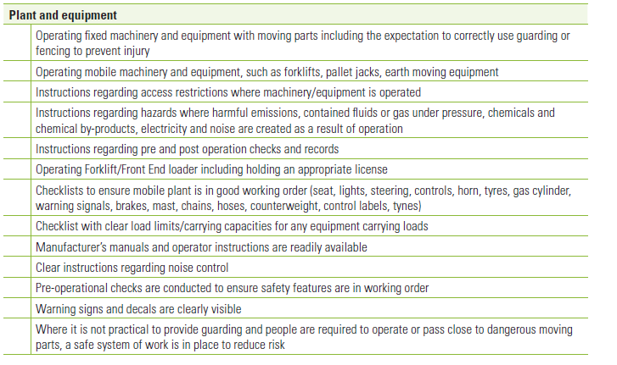
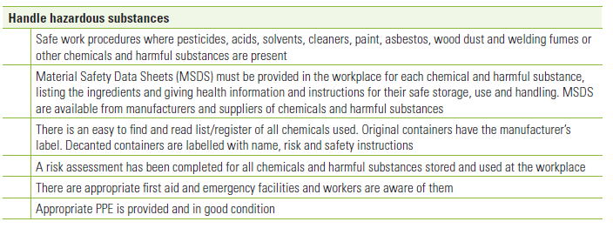
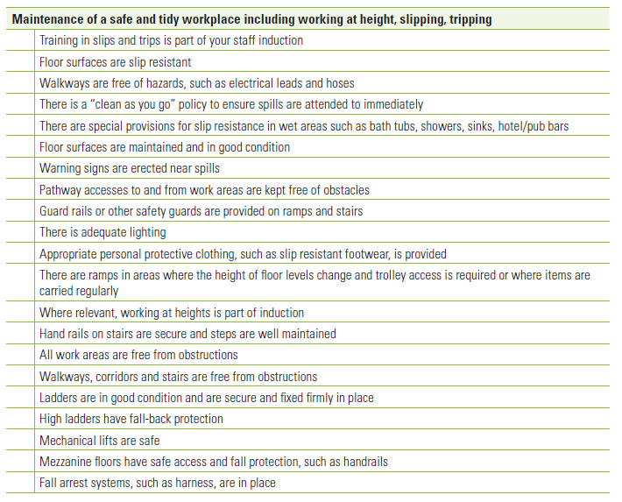
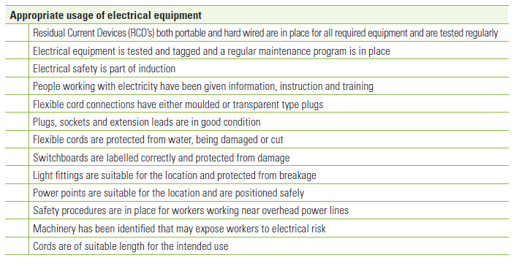
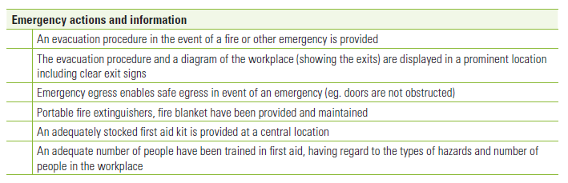
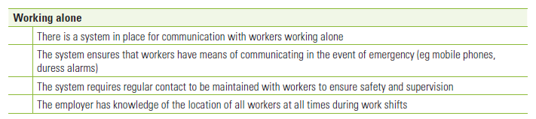
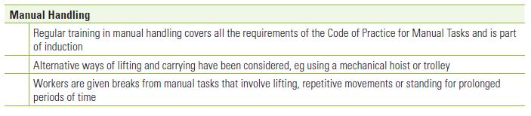
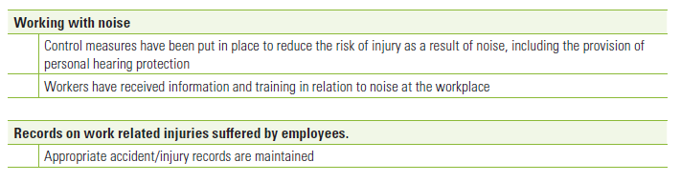

Activity 2.3 Hazard Identification - Chisholm
Take a walk around the campus looking for any OH&S hazards, list below

Activity 2.4 Hazard Identification - Workplace
Identify the tasks that you perform, the hazards and hazard type. Use the list of typical OH&S hazards below
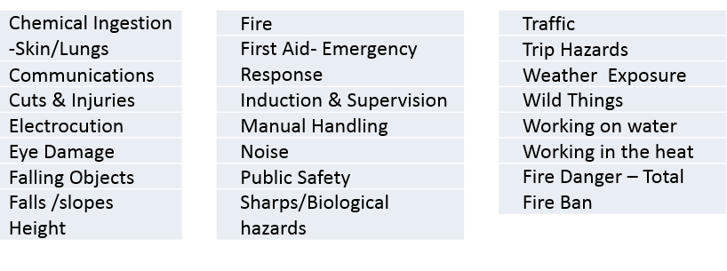
Workplace Task or Activity | Hazard | Hazard Type

Activity 2.5 Risk Assessment & SWMS
Complete the SWMS below using the Risk Analysis Matrix

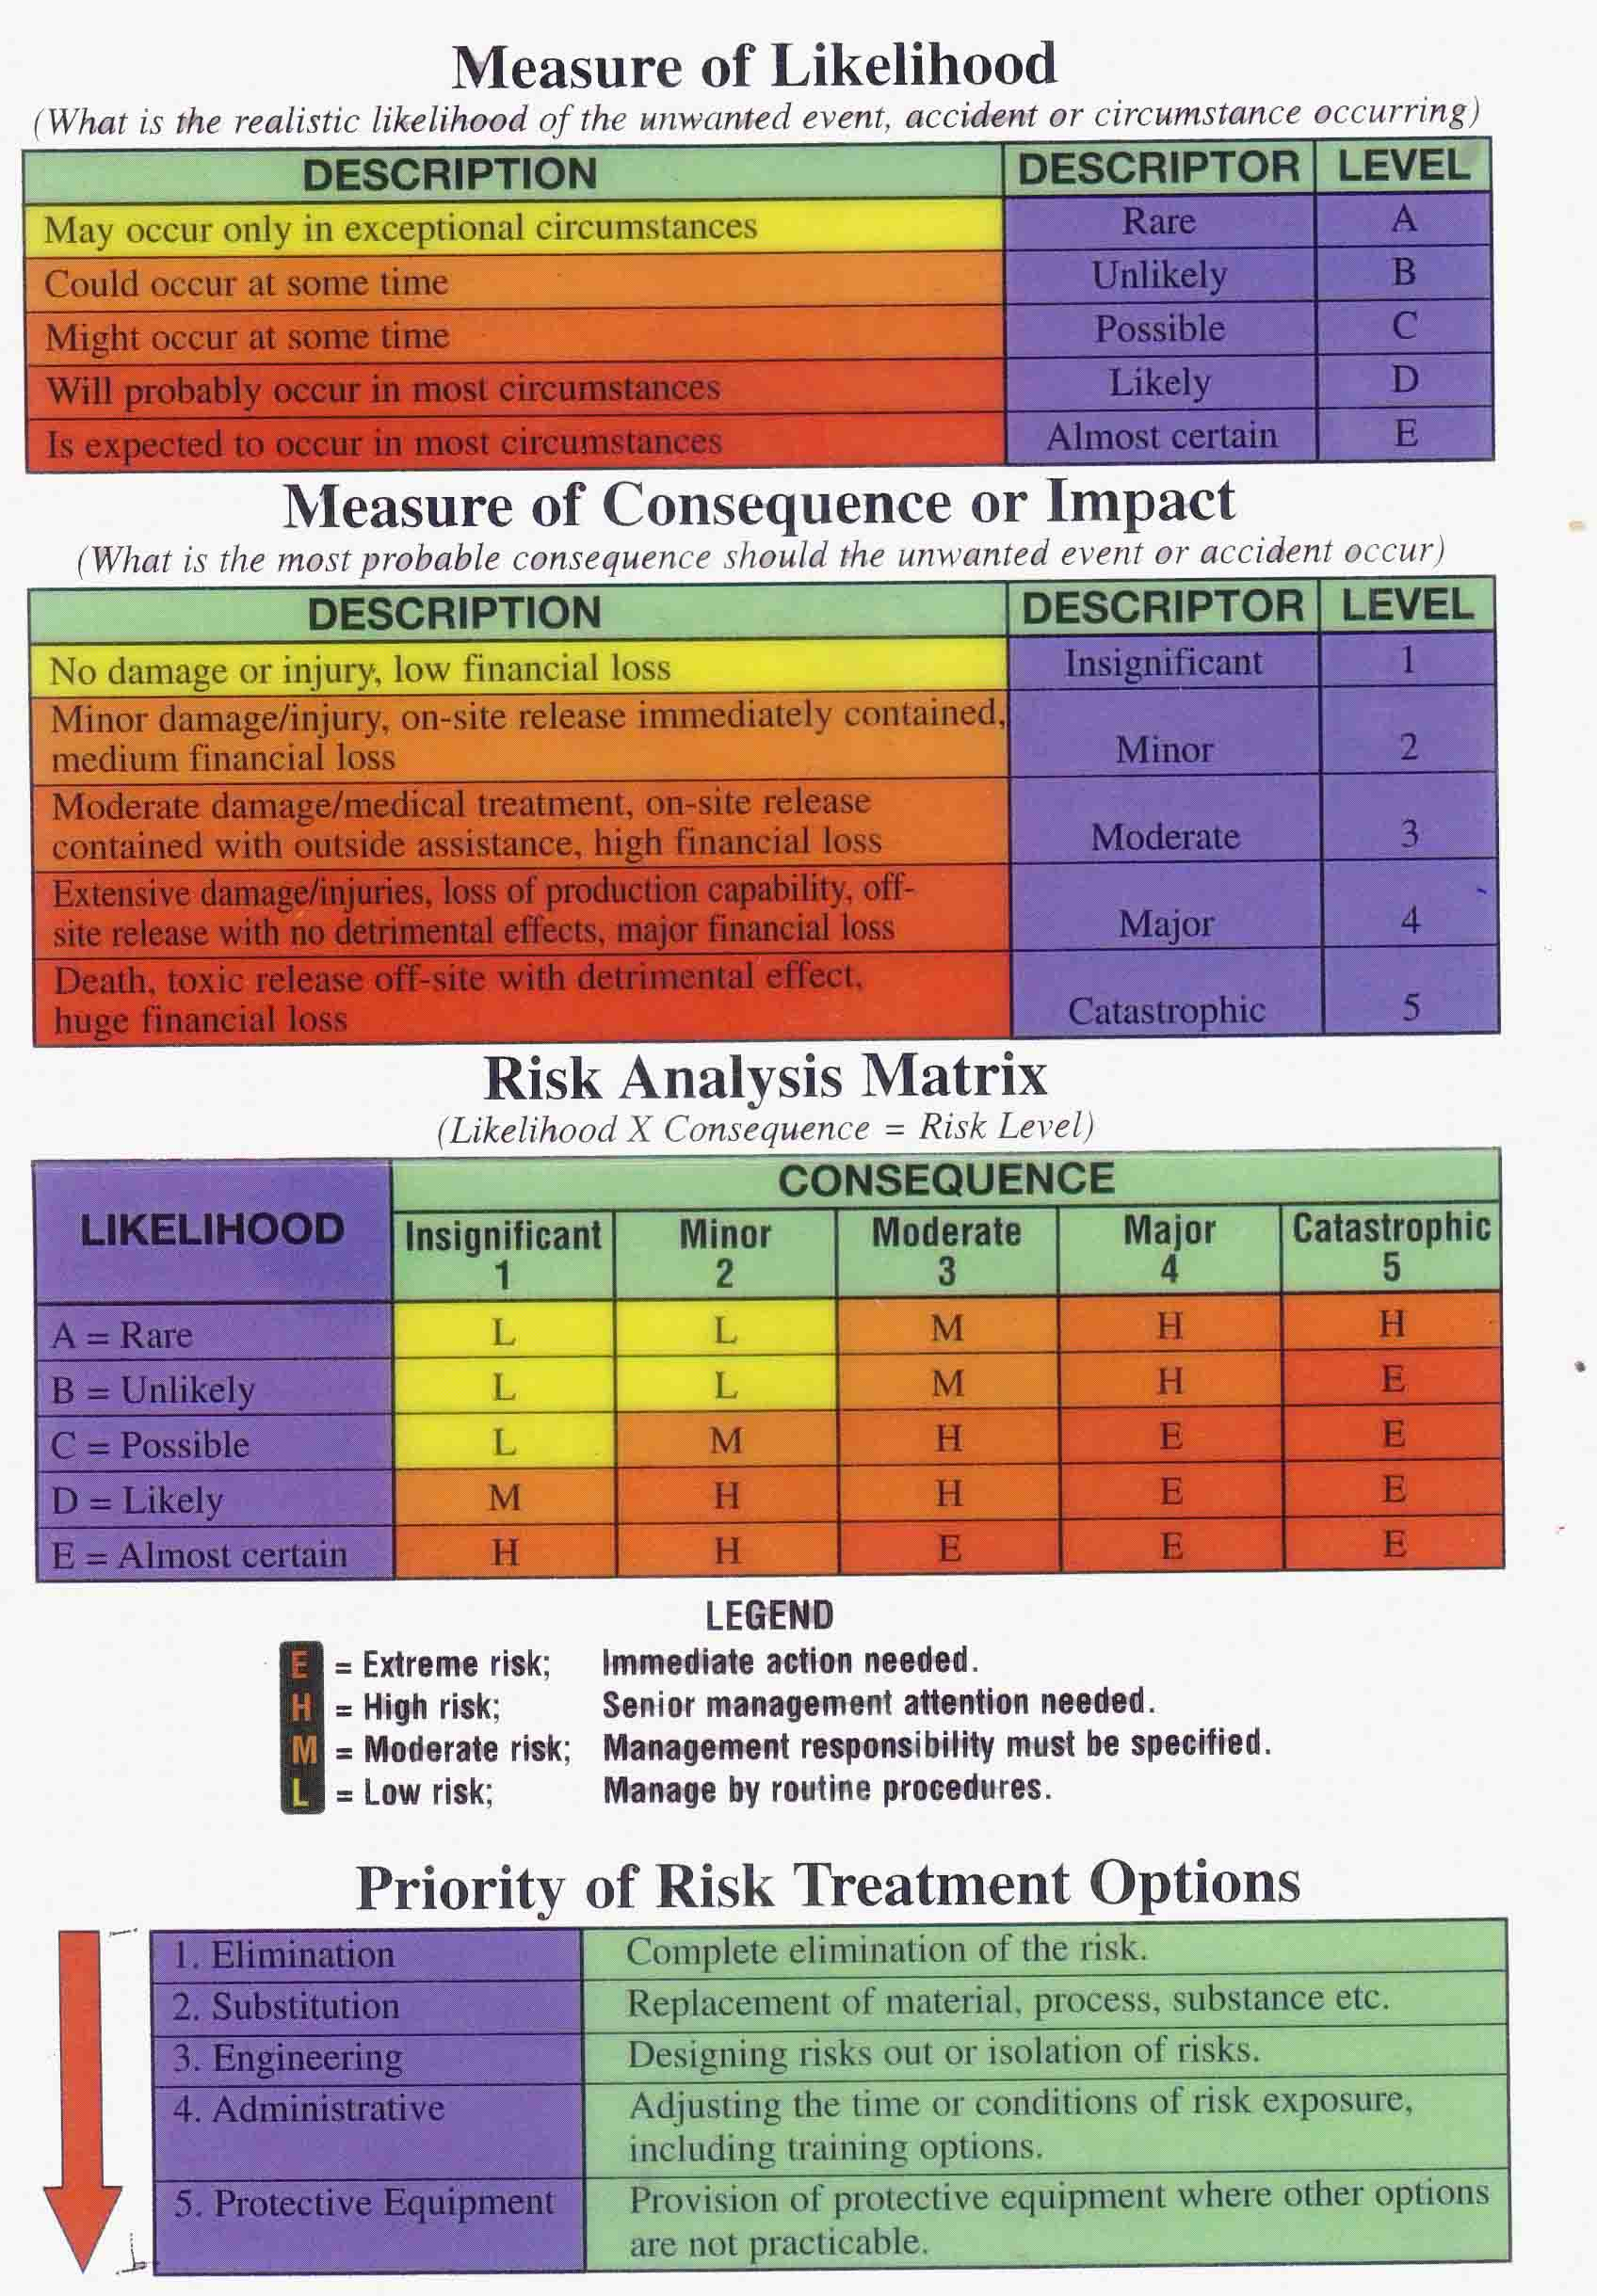

Safe Work Methods Statements (SWMS)
Site Name: |  |  |  |  |  |  |  |  |  | Site Supervisor |  |  |  |  |  | signed
Project: |  |  |  |  |  |  |  |  |  | Date/s
Staff name: |  |  |  |  |  |  |  |  |  |  |  | Activities |  |  |  |  |  |  |  | Site Location/Address for Emergency Purposes
Activity  List the tasks required to perform the activity in the sequence they are carried out. |  |  | Hazards/Risks (See over for a list of Hazards)  Against each task list the hazards that could cause injury or environmental damage |  |  | Likelihood of the unwanted event or circumstance (A-rare to E-almost certain) |  |  | Measure of the Consequence of the event 1 insignificant to 5-Catastrophic |  | Risk Score – Low Moderate High Extreme |  | Risk control measures List the control measures required to eliminate or minimise the risk of injury arising from the identified hazard |  |  |  |  | Who is responsible? to implement the control measure identified |  |  |  | Residual likelihood | Residual Consequence |  |  | Residual Score
Remember: Each SWMS must be site specific and may change during the job.
Activity  List the tasks required to perform the activity in the sequence they are carried out. | Hazards/Risks (See over for a list of Hazards)  Against each task list the hazards that could cause injury or environmental damage | Likelihood of the unwanted event or circumstance (A-rare to E-almost certain) | Measure of the Consequence of the event 1 insignificant to 5-Catastrophic | Risk Score – Low Moderate High Extreme | Risk control measures List the control measures required to eliminate or minimise the risk of injury arising from the identified hazard | Who is responsible? to implement the control measure identified | Residual likelihood | Residual Consequence | Residual Score

All staff / Subcontractors must be inducted in the use of equipment and activities for the job . If staff not inducted then do so before the job commences

OH&S Hazards |  |  |  |  |  | Environmental Hazards
Chemical Ingestion -Skin/Lungs |  | Fire |  | Traffic |  | Chemical Spill Risk
Communications |  | First Aid- Emergency Response |  | Trip Hazards |  | Disease spreading
Cuts & Injuries |  | Induction & Supervision |  | Weather Exposure |  | Erosion Potential
Electrocution |  | Manual Handling |  | Wild Things |  | Habitat destruction
Eye Damage |  | Noise |  | Working on water |  | Off target Spray damage
Falling Objects |  | Public Safety |  | Working in the heat |  | Weed Spread Risk
Falls /slopes Height |  | Sharps/Biological hazards |  | Fire Danger – Total Fire Ban

Activity 2.6 PPE
Each group to choose a task, locate the appropriate PPE in Chisholm store and wear. Then present to class the task and PPE items that are being worn. Explain the hazards that the PPE is protecting the worker from.

Activity 3.1 Safe Work Procedures
In table groups one person is to induct all others in a Safe Working Procedure, inductees to answer question sheets correctly.

Activity 2.2 Develop a Safe Working Procedure

Activity 3.3 Pre-start Checks
Take a walk to storage shed and look for pre-start and maintenance information for tools, small plant and equipment. List the items you found and pre-start and/or maintenance info. If there is no pre-start or maintenance info list what you think should be done for the equipment
Item | Pre-start info present – describe | Maintenance Info present describe

Activity 3.4 Incident Report Form
Fill out the incident form for an imagery or real workplace incident
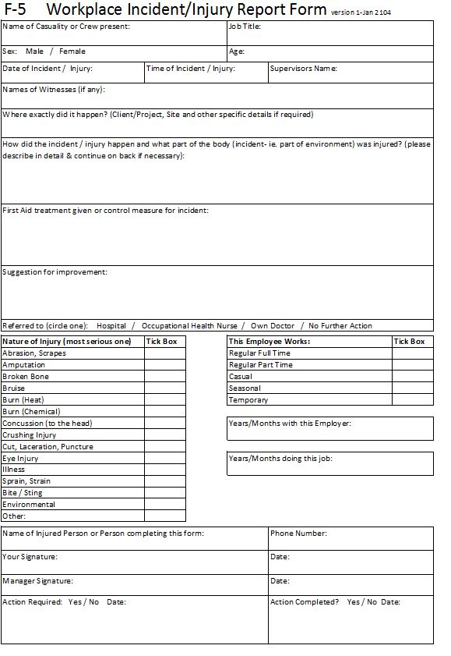
Activity 3.5 Warning Signs
Sign hunt around campus -
Describe the sign | Where is it located? | What is it telling you? | Is the sign a Caution, Mandatory, Dangerous Goods, Fire or Emergency Information Sign?

Activity 3.6 MSDS
Review a MSDS to answer the following
What is the product?

What is it used for?

What are the risks associated with using the product

What are the safety instructions related to using the product in your workplace?

