



Design – Module 2:
Design for Water Conservation

Key Areas for Water Conservation
- Stormwater amelioration (Water Sensitive Urban Design)
- Greywater recycling (wastewater re-use) (See Design module 3 - Water recycling)
- Water harvesting (rainwater) (See Design module 4 – Water capture)
- Irrigation (See Design module 5 - Irrigation)
- Plant Selection (Refer to Design module 6 – Plant Selection)

Water Sensitive Urban Design

Water Sensitive Urban Design (WSUD) is a storage-orientated system that provides for temporary retention of stormwater on site. WSUD seeks to approximate the natural water balance on-site prior to the land being built on. It achieves this by slowing the water velocity of stormwater run-off, providing natural filtration, storage and infiltration. The water eventually reaches the river, lake or ocean but has been cleaned and filtered by the soil and used by plants before it gets there.
The objective is to minimise impervious surfaces so that the least amount of water flows off-site into the stormwater system. At the scale of the individual housing lot, WSUD uses permeable paving, infiltration trenches, soakwells (rain gardens), drainage swales and garden beds to detain the water and allow it to percolate into the soil. The slope of the block and the depth and type of soil determine the application of each of these practices.
Water Sensitive Urban Design:
- provides improved aesthetics and comfort associated with more vegetation;
- habitat for native wildlife is improved;
- the area is cooler in summer;
- reduces the need for garden watering and can therefore decrease water bills;
- erosion and the downstream effects of stormwater pollution on nearby rivers, lakes or ocean are reduced.
WSUD is now a focus of the new subdivision provisions of Clause 56, developed by the Victorian Government. More information can be found at:
http://www.dse.vic.gov.au/DSE/nrenpl.nsf/LinkView/69E6051516DFA418CA256DDD000F402EC4EB543DC77A77864A256DEA002C5760
Utilising Stormwater
Information taken from - http://www.greenhouse.gov.au/yourhome/technical/fs24.htm
Stormwater is pure rainwater plus anything the rain carries along with it. Stormwater should be considered a valuable resource.
In urban areas stormwater is generated by rain runoff from roof, roads, driveways, footpaths and other impervious or hard surfaces. In Australia the stormwater system is separate from the sewer system. Unlike sewage, stormwater is generally not treated before being discharged to waterways and the sea.
Poorly managed stormwater can cause problems on and offsite through erosion and the transportation of nutrients, chemical pollutants and sediments to waterways. Stormwater is a useful resource that can replace imported water for uses where high quality water is not required, such as garden watering.
Stormwater Management
There are a number of steps can be taken to better manage stormwater, and reduce the environmental impact of building and landscaping.
Avoid cut and fill on blocks when preparing the building foundations. Attempt to maintain the existing topography and drainage pattern.
Retain vegetation, particularly deep-rooted trees. These lower the water table, bind the soil, filter nutrients, decrease run-off velocities, capture sediment and reduce the potential for dryland salinity.
Detain stormwater on the site where practicable through use of permeable paving, pebble paths, infiltration trenches, soakwells (rain gardens, see further down for more information), lawn, garden areas and drainage swales (see further down for further information).
Reduce erosion potential on site during building works by minimising the time that land is left in an exposed, unstable condition. Employ sediment traps and divert 'clean' stormwater around the disturbed site.
See our document on Site Management & Practices
Minimise the area of impervious surfaces such as paved areas, roofs and concrete driveways. See further down for information on permeable paving.
Grade impervious surfaces, such as driveways, during construction to drain to vegetated areas.
Harvest and store roof water for use. See our document on rainwater capture and use.
Do not build on flood plains as the land may be periodically subject to inundation and may possess a high water table. Councils can advise on the 1 in 100 year flood level.
Be mindful of illegal cross-connections with sewer and stormwater.
Rain Gardens
Rain gardens (this is a user-friendly name for biofiltration, bio-remediation, or sand filters) are a useful adjunct in reducing the load on the stormwater system. It has been found that rain gardens are more efficient than wetlands at removing Nitrogen in particular. A wetland-sized rain garden is currently being built at Carrum Downs, by Ecodynamics. Below is a simple version of the rain garden showing its suitability for a small site.

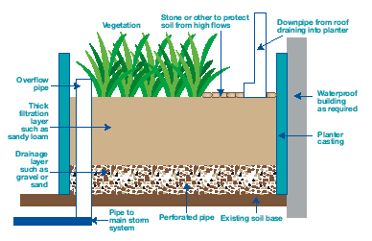

Image from Rain Garden pdf available from Melbourne Water’s website:
http://www.melbournewater.com.au/content/library/wsud/sustainable_urban_design/raingardens.pdf
Refer to the document on Plant Selection for suitable plant species for rain gardens.
Drainage Swales or Bioretention Swales
Drainage swales or bioretention swales, as they are also called, are efficient at removing nutrients from run-off water. They also retard the flow of water in storm events.

The Australian Garden at Royal Botanic Gardens Cranbourne provides a fine example of a drainage swale (below). In this instance run-off water from the road is captured. Vegetation not only takes up the water but nutrients and pollutants as well, so any water that does eventually enter the stormwater system is a lot cleaner (and there’s a lot less of it). The water is also recharging the soil.

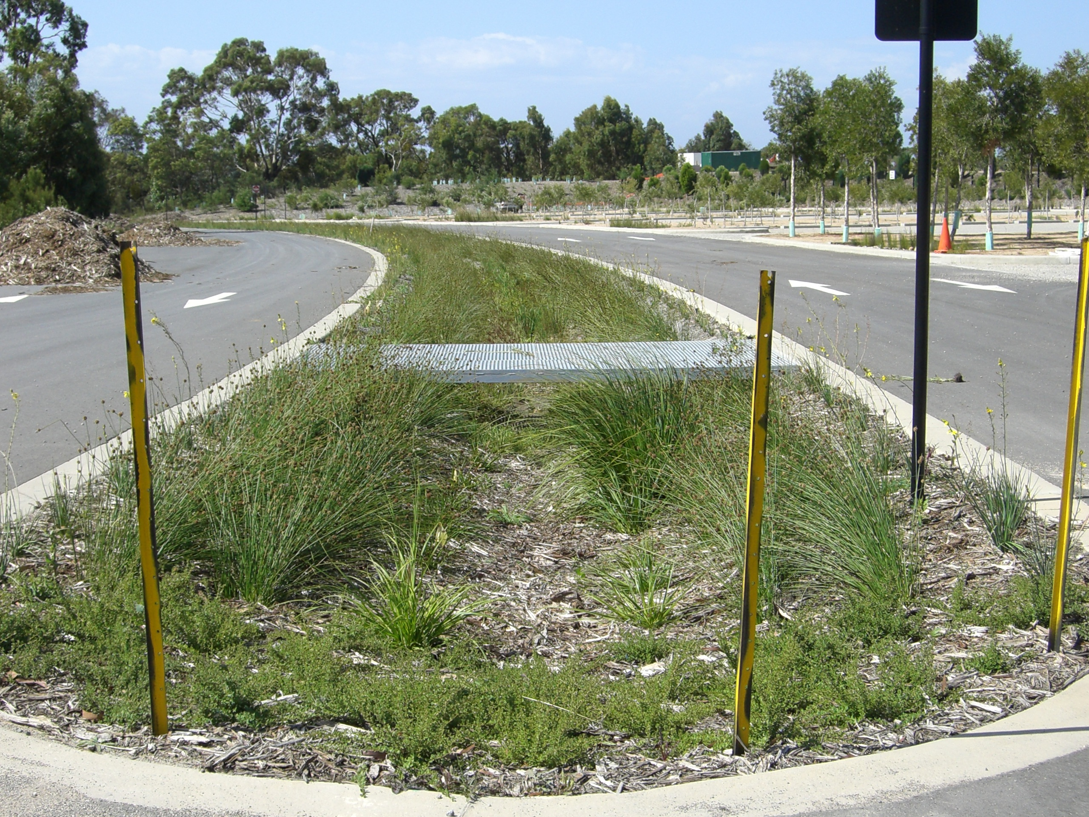Image: Frances Saunders

Stormwater flows into the swale and as it does, coarse and medium-sized sediments settle. The stormwater then percolates through the trench, which contains a sand or gravel medium. The sand or gravel filters finer sediment, and the vegetation takes up nutrients. Under the medium, perforated under-drains collect the water, which can be stored or released into the stormwater system.

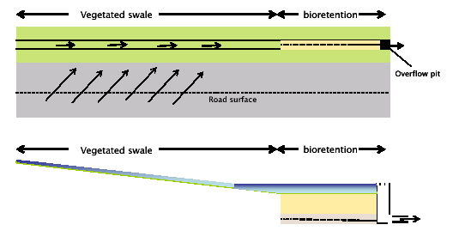
Figure 1: Bioretention Swale with Bioretention Component at the most Downstream Section.

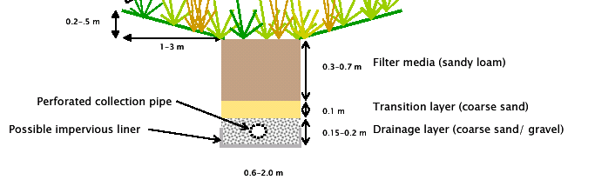
Bioretention swales are best used as a source control at the head of a ‘Treatment Train’ and may
be located within private property, parkland areas, easements, carparks and along roadway
corridors (i.e within footpaths and centre medians).

Courtesy of Brisbane City Council.

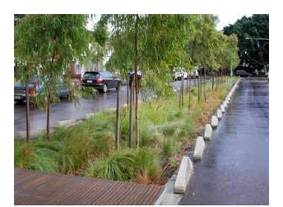
Bioretention trench in Zetland, NSW. The kerb prevents vehicle access while the breaks in the kerb allow stormwater inflows.

Information and images courtesy of Brisbane City Council, practice note
http://www.brisbane.qld.gov.au/bccwr/lib184/wsud%20practice%20note%2003%20bioretention%20swales.pdf

This document provides detailed information on hydraulic design considerations. Brisbane City Council has also developed other practice notes in the series, which are well worth investigating.

Bog Gardens and Ephemeral Water Features
These features also encourage stormwater to stay on site to recharge groundwater but have the added advantage of being suitable frog habitat. They are best considered in the lowest lying areas of a landscape, thus utilising natural drainage lines.

Stormwater Harnessing Watchpoints
When seeking to install or maintaining subsurface units such as infiltration trenches the following things should be considered:
Soil Type - check the soil type. Sandy soils are excellent for infiltration but clay soils tend to become waterlogged. This will affect the efficiency of some of the water sensitive design solutions. For example, water sensitive design in heavy clay soils may need to be supplemented with traditional conveyancing methods.
Soil Depth - ensure that you have sufficient soil depth. Areas with shallow soil underlain by impervious rock such as granite, shale or limestone may impede infiltration and may require some stormwater pipes to remove water for discharge off site.
Groundwater - determine the depth to groundwater.
A high groundwater table may reduce the effectiveness of infiltration methods during storms.
Slope - ensure that the stormwater design accounts for the terrain as severe slopes increase run-off velocities.
Reduce pollution resulting from fertiliser, herbicide and pesticide application. Do not over-use products. Follow the manufacturer's instructions regarding amount and frequency of application. Look for organic alternatives.
Avoid the use of solvent based paints. When using water based paints, clean brushes and equipment on a lawn area to trap contaminants before they reach waterways. Plant based paints are the most environmentally benign.
Regulations - check with Council before employing water sensitive design solutions. Some components of WSUD may conflict with local government drainage regulations.

Permeable surfaces

A large body of literature links impervious surfaces to a wide variety of environmental problems. The relationship is so established that an old adage could be truncated to ‘the road to Hell is paved…Period’.
(from the Forward to the book, Porous Pavements, by Bruce K. Ferguson, published by Taylor & Francis)

Before any discussion on the importance of permeable surfaces and how to achieve them, it is important to note that there are times when permeable surfaces are not appropriate, and in fact, pavement should remain dense and impervious:

  - Where run-off from the surface is a resource that can be captured into special swales or cisterns and used for irrigation or other purposes.
  - On old industrial sites and the like, where dense pavement will prevent rainwater from percolating into and through toxic deposits in the soil, and thus preventing leaching of pollutants into aquifers, streams and the wider environment.

Importance of permeable/porous surfaces
- Clean water - Impervious paving allows stormwater and especially all the pollutants that it contains (particularly first-flush) to runoff untreated into streams, causing erosion, habitat destruction, the death of fish and other biota, and often widespread flooding downstream. Porous pavements protect urban watersheds and aquifers by treating rainwater where it falls. By spreading stormwater infiltration over large areas, the underlying soil ecosystem has an opportunity to biodegrade pollutants and store subsurface water.
- Tree health- Urban trees, especially street trees, thrive and grow in conditions where permeable paving is installed.
- Cooler Cities – The heat-island effect of cities is now well understood. Over 90% of the increase in temperature is due to urban construction materials. By reducing vast expanses of paving in favour of a combination of other paving such as ‘grass pavements’, which can be a mix of grass/groundcovers and paving, or grass reinforced by geocells or concrete grids.

Environmental benefits
Downstream environmental benefits of reduced stormwater pollution (from the NSW EPA):
- Rivers, lakes and beaches will be cleaner and safer for swimming;
- Flooding will be reduced;
- Waterways will look cleaner; and
- Councils will need to spend less money emptying stormwater traps.
Water Sensitive Urban Design is applicable on all sites but the degree of application will vary according to the site's opportunities and constraints. All sites should be able to maximise permeable surfaces such as garden beds, lawns, porous paving and paths.
Reference: Porous Pavements, by Bruce K. Ferguson, 2005, (published by Taylor & Francis)
This book also contains more detailed information on:
Porous pavement structure
Porous pavement hydrology
Porous pavement tree rooting media
Porous aggregate
Porous Turf
Plastic Geocells
Open-Jointed paving blocks
Open-celled paving grids
Porous concrete
Porous asphalt
And other porous surfaces

Australian Examples
Refer to the following pdf for a technical review of permeable paving in a Sydney environment which showed that the imperviousness of paving was reduced from 45% to 3% and water quality in the runoff increased as the paving intercepted many pollutants. In this instance, Rocla ECOLOC pavers were used. These are interlocking concrete pavers that utilise drainage voids between the pavers. Not only is the paving permeable but it has good load bearing qualities.
http://www.wsud.org/downloads/Info%20Exchange%20&%20Lit/WSUD_04_Conf_Papers/WS040120.PDF

Examples of other permeable paving types
Atlantis Turf Cell® and Gravel Cell® can be used in any situation where low to medium use parking surfaces, access roads and driveways are required. The sub-base required for cells is equal to or less than the sub-base required for concrete or bitumen. Not only do these create a permeable surface, but they also have high load bearing capacity, are easy to install, and eliminate the need for surface drains (eg concrete pits or grated trench drains).
It is very important to refer to the manufacturer’s technical specifications regarding installation, to ensure load bearing capabilities, where necessary, in conjunction with permeability.
Other Design Strategies
Take advantage of the natural site conditions wherever possible. The overall goal these days is to keep water onsite and utilise it (as much as is practicable) rather than drain it all off as quickly as possible.
For example, utilise depressions, rather than eliminate. Other strategies could include:

- Contour sloping garden areas to reduce surface flows
- Build terraces on very steep slopes. The following website provides some advice which may be useful regarding the construction of suitable terraces: http://sydney.foe.org.au/water/WSUD_home_garden.html

Swimming Pools and Water Features
Water loss from a still body of water can range from 5-10 mm per day during the warmer months of the year. A feature that splashes or mists can further increase the loss, especially in windy conditions.

Pool covers can reduce evaporation by 95% and also decrease the level of maintenance required. Automatic pool covers can be installed at the same time as the pool and are designed to be as unobtrusive as possible.
Consideration should be given to the location of water features. A feature in full sun is subject to far greater levels of evaporation and will require higher levels of maintenance.
Be mindful of water restrictions with regard to filling and topping up of pools and water features.

