



Design – module 8:
Specifying for a Sustainable Landscape

Where does it come from and where does it go? The materials that you use in landscapes can have an impact on an ecosystem across the other side of the globe.

Material Specifying

The choice of materials available to landscape professionals is ever increasing. Selecting the most environmentally sustainable option can be extremely challenging.

Transport
The transport of product around the globe can quickly increase its environmental impact. A product that may be the most sustainable option in one area may not be in another. Sourcing local product is always the best option when comparing the environmental impact of two otherwise identical products.

Recyclability

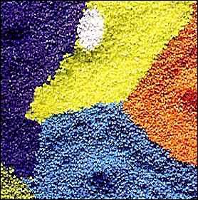
Product recyclability should be considered. This refers to how easily it can be reused or recycled into another product once it has reached the end of its current working life. The materials used in rainwater tanks are examples of products that have varying levels of recyclability. Recycling can involve considerable energy input, especially plastic products, so be mindful that recycling is not always the be all and end all of using resources wisely. However, generally speaking, the energy input required to recycle is less than that of producing a new product.

Toxicity
Some of the materials used in landscaping can be very toxic to the health of humans and the environment.

Caution should be taken when specifying products that contain:
- Chlorinated building materials (eg PVCs)
- VOC (Volatile Organic Chemicals) producing substances (eg paints and varnishes)
- Heavy metal additives and components (eg Mercury, Lead and Cadmium containing products). Some synthetic fertilisers contain heavy metals.
- Certain wood treatments (eg chromium copper arsenic (CCA) treated pine)

There is a wide range of low or non-toxic products available that are less harmful to the environment and human health. A number of organisations and companies specialise in the sourcing and sale of environmentally responsible products and materials.

Material Source

The destruction of forests and river systems across the globe through mining and logging has a significant impact on the ecology of these areas. The result can be species extinctions and long term/permanent damage.

Timber
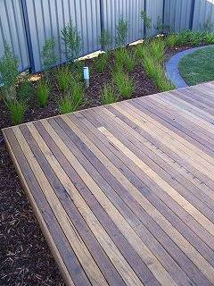
Use recycled timber where possible. There are a number of recycled timber businesses in each state of Australia. These products can be remilled if required for uniform sizing or to bring out the natural colour of the wood for staining or varnishing.

If recycled timber is not appropriate, plantation timber should be sourced from an operation that is well managed. Eco labelled timbers are normally the safest option as this gives some level of security that the product has been sustainably harvested.

Non-timber options may also be suitable, such as recycled plastic decking and edging. These are available in a range of finishes.

Rainforest timbers such as Mirboo and Teak should be avoided due to the environmental damage and habitat loss caused by the extraction of these timbers.

Hard Landscaping materials
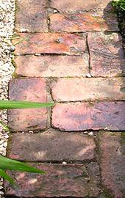
Reconditioned bricks and pavers are salvaged from demolition sites, sorted and cleaned for reuse. Reconditioned bricks and pavers are regularly used for paths, driveways and walls to create a rustic effect. Alternatively they can be rendered or bagged if a more modern appearance is required. Reconditioned bricks prevent the material from entering landfill and require less energy to produce compared to new materials.

Flooring material can be made from a range of recycled materials not traditionally considered. As technology improves, recycled pavers and flooring constructed from recycled plastics and other materials are becoming cheaper and more stylish.

Crushed concrete is an alternative to crushed rock and has all the same characteristics. The product is concrete that has been sourced from a range of demolition sites and crushed, any foreign matter is removed and the resulting material has the same if not higher standards as the equivalent crushed rock.

Mulches, compost and soil

Pebbles
Decorative pebble mulches come from a range of sources. Most commonly the polished style pebbles are sourced from active stream beds and should be avoided. If this style of product is required, search for quarried materials that are the by-product of an alternative industry. An example of this are the envirSelect range of pebbles available from Décor Pebbles. These pebbles are sourced as a by-product of quarrying larger slabs of marble, jade and granite.

Locally sourced quarried pebbles are less destructive to the environment and require less transporting. These pebbles are available in bulk, which reduces packaging requirements compared to the imported pebbles that are normally sold by the bag.

Organic Mulches
Similar to timber, the type of mulch that is used and where it is harvested from can have a significant influence on its sustainability.

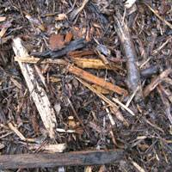
Mulches that are sourced from old growth forests are not recommended due to the negative impact of clearing on these environments.

Mulches sourced from plantation grown timber are a by-product of the timber industry and are suitable for a wide range of applications.

Numerous other agricultural industries create by-products that can be used for mulching and sugar-cane is such an example. The impacts that these products may have on the environment are dependant on the farming practices of each particular crop and should be considered prior to specifying their use. And the distance to be transported is another consideration.

Recycled organic mulch, processed through the council green waste system is sourced from residential curb-side bin services, refuge centres and commercial operations. It is composted to a temperature sufficient to prevent the survival of any weed seeds or pathogens. The composting process also creates a more uniform appearance to the mulch.

Compost
Make sure that any compost is sourced from material that is recycled. The ideal compost source is from the garden itself, so encourage clients to use compost bins whenever practical. Commercially available compost collected from residential green waste, councils and refuge centres is high in quality, consistent and available on demand. Recycled compost can be purchased from most landscape supplies yards or directly from the manufacturer. Avoid composts that are generated from non-plantation timber operations.

Resource management

Avoidance of tipping
Landfills are overflowing with millions of tons of waste per year and approximately 40% of this is from construction and demolition activities (approximately 50% residential and 50% commercial). Avoiding tipping not only helps the environment; it also helps to contain costs. There are a number of steps that can be taken to help keep resources out of landfill.

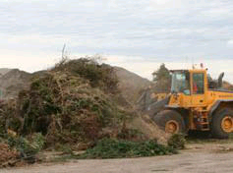
During the construction and throughout the life of the site it is inevitable that some waste will be created, these materials should be separated and recycled whenever possible. It may be possible to hire specialist skips depending on the amount of waste created. Companies such as the Alex Fraser Group offer bin services that sort and recycle construction waste from site.

All green waste should either be composted onsite or sent to a facility where the material can be reused. There are a number of centres for collection of green waste and these can be contacted through local councils.

Lawn clippings are best left where the lawn is cut. Grass recycling using a mulching mower or even a regular mower can reduce mowing time by up to 50% and decrease fertiliser requirements by between 15 and 25 percent.

Re-using material
Re-using material prevents unnecessary landfill. This is best done onsite by reusing materials that may have been removed during the demolition phase of the project. Timber, bricks and soil can commonly be reused.

Returning unused product
Disposing of unused product into landfill can be avoided by arranging with the distributor to take back anything not required.

Over ordering
Only order the amount of product that you require when you need it. If possible purchase products pre-fabricated before they come onsite. Prefabricated products can cut waste by over 50%.

Designing with standard material sizes
Designers can prevent large amounts of waste by designing and specifying standard sizes. Designing a paved area to match the size of the pavers prevents excess waste caused by cutting. Similarly designing decks and structures to standard lengths will also reduce off cuts.

Equipment emissions control
In many situations it may not be necessary to use petrol driven power equipment. The use of a leaf blower may be replaced with a broom, or a brush cutter with a lawn edger, 2-stroke engines can create high levels of pollution if not regularly serviced. Damage is caused to equipment that is not correctly maintained, which decreases working lifespan, thus requiring early replacement.

Vegetation management

Appropriate plant selection
Selecting plants that have a growth habit suited to the area planted helps to minimise waste. If a tree does need to be shaped, do so early in its life. A mature tree is harder to prune and the larger wound takes longer to recover, increasing the chance of infection.

Selecting species with slower growth rates reduces the amount of pruning required. These species normally have a longer life expectancy than the faster growing alternatives

Replacing annuals with summer and winter flowering perennials decreases the amount of green waste created while still maintaining a colourful garden. If annuals are requested, try to limit their use as much as possible. Select species with low water needs and dead head to encourage prolonged flowering. Once the annuals have finished flowering, either compost or send the material to a green waste facility for processing. Refer to Design module 6 – Plant selection.

Soil Management
Unnecessary excavation should be avoided. Attempts should be made to use the natural topography of the land wherever appropriate. If soil does need to be excavated it should be reused onsite or transferred to a facility for processing. A number of councils also offer a clean fill registry service for people that have or require clean fill.

Information Sources
Timber sourcing recommendations for Australian Users www.rainforestinfo.org.au

Guide to recycling services in Victoria www.sustainability.vic.gov.au

EPA Victoria booklet The resource efficient builder, A simple guide to reducing waste Easy Guides Australia

Thompson, W. and Sorvig, K. (2000) Sustainable landscape construction: A guide to green building outdoors Island Press, Washington, USA.

Managing a waste-efficient landscape www.ciwmb.ca.gov

Image sources

Recycled plastic
http://www.ecplaza.net/

Decking
http://www.timberzoo.com.au/

Reclaimed brick path
http://www.turning-earth.co.uk/recycling.htm

Organic mulch
www.baag.com.au

Green waste facility
http://www.greenplanet.net.au

