Flying-foxes
Flying-foxes are mammals and are members of the Pteropididae or fruit bat family. They have the largest body size of all bats.
The grey-headed flying-fox (Pteropus poliocephalus) is the largest member of the family. Its wingspan can reach one metre and it can weigh up to one kilogram.
Flying-foxes have large eyes, which are highly adapted for day and night vision and particularly suited to recognising colours at night. Colour recognition is important for flying-foxes when searching for food.
There are four species native to mainland Australia: the little red flying-fox, the black flying-fox, the spectacled flying-fox and the grey-headed flying-fox.
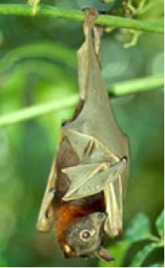  Little red flying-fox | 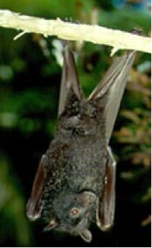  Black flying-fox | 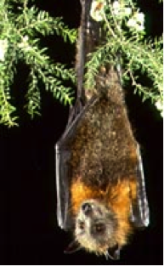  Grey-headed flying-fox | 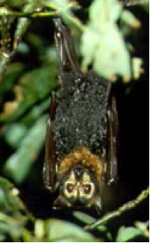  Spectacled flying-fox
Images: Bruce Thomson, QPWS. Courtesy Queensland Flying-fox Consultative Committee.
The grey-headed flying-fox is the only species permanent to southern Victoria. The little red flying-fox is a semi-permanent resident in northern Victoria.
Flying-foxes are migratory animals and in Melbourne colony numbers fluctuate with the seasons. There are more flying-foxes in summer and fewer in winter.
Melbourne's Royal Botanic Gardens became home to a permanent colony of grey-headed flying-foxes in 1986 after years of seasonal roosting.
In 2003 their numbers peaked at 30,000 in summer, with 8,000 staying through to winter.
Having so many flying-foxes roost all year round in a small and sensitive area of the Royal Botanic Gardens was damaging heritage-listed vegetation.
To remedy the situation, in March 2003 the grey-headed flying-fox population was successfully moved to a more suitable location at Yarra Bend Park, Kew.

About flying-foxes

Distribution and habitat
Flying-foxes are found throughout tropical and sub-tropical Asia and Australia and on islands of the Indian and western Pacific Oceans.
They are nomadic animals and their movement patterns and local distribution are determined by variations in climate and the flowering and fruiting patterns of their preferred food plants.
The four flying-fox species found in Australia occur mostly in northern and eastern temperate and sub-tropical coastal areas.
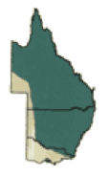  Little red flying-fox | 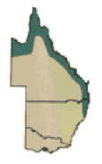  Black flying-fox | 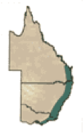  Grey-headed flying-fox | 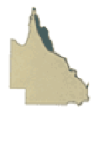  Spectacled flying-fox
Maps: Courtesy Queensland Flying-fox Consultative Committee.
Flying-fox numbers in Australia have changed markedly since European settlement.
Loss of natural habitat and food supply in New South Wales and Queensland due to land clearing and human culling has rapidly reduced numbers of some species in eastern Australia.
Grey-headed flying-fox and spectacled flying-fox numbers have decreased to such an extent that they are both listed as vulnerable under the Commonwealth Environment Protection and Biodiversity Conservation Act 1999.
Flying-fox distribution has also changed over the past 30 years due to loss of habitat, the creation of new habitat and the year-round food supply in suburban areas.
For example, the range of the grey-headed flying-fox has contracted in the northern area (southern Queensland and northern New South Wales) and expanded southwards into Victoria.

Camp
Flying-foxes roost (rest hanging upside-down) in a wide range of warm and moist habitats, including gullies in lowland rainforest, coastal stringybark forests and mangroves, often beside a creek or water.
They usually set up camps in tall and reasonably dense vegetation, but they are also tolerant of people.
The permanent camp sites established in suburban areas of Brisbane, Sydney and Melbourne enable the animals to take advantage of conditions provided by humans.
There are more reliable food supplies from well-watered trees, and street lights may be used as a navigational aid.
Camp sites can be permanent or temporary and can include up to tens of thousands of individuals.
During the breeding season the camp size can change dramatically due to the availability of food and the arrival of animals from interstate.
For example, during summer to autumn, the grey-headed flying-fox camp at Yarra Bend Park, Melbourne, expands from around 6,000 to more than 30,000 individuals.
Camp sites where young are born become very important to flying-foxes. Some camps in New South Wales have been used for over a century.
While in camp, flying-foxes hang upside-down in trees, usually folding their wings beside or around them.
The continual use of camp sites by flying-foxes, such as during the breeding season, can damage vegetation by stripping branches of leaves.
Camps have their own smells and sounds. Males use strongly-scented secretions to mark mating territories and make loud calls when defending those territories and during mating.

Behaviour and breeding
Flying-foxes are intelligent, social and nocturnal.
Around dusk each evening, adults and adolescents leave the camp to search for food.
The timing of departure appears to be influenced by availability of food. If food is in short supply or a long distance away, they will leave before sundown.
When food is plentiful or nearby, or when there is a full moon, they will leave well after dark.
Flying-foxes are vocal animals. More than 30 different calls have been recorded for grey-headed flying-foxes.
The different calls are associated with specific behaviours such as mating, finding young in the camp and in territorial disputes over food.
Loud calls may be heard during mating and when defending territory.
Grey-headed flying-foxes conceive in March and April, but mating activity can occur over many months.
Flying-foxes are placental mammals, giving birth to live young. They give birth to a single young each year from about September to late November.
The baby clings to the mother's belly for the first three weeks until it becomes too heavy to carry. At three weeks old the young is left at a crèche in the centre of the camp at night while its mother flies out to feed.
Mothers return just before dawn and can recognise their young by their smell.

Diet
Flying-foxes prefer blossom, nectar, fruit and occasionally leaves of native plants, particularly eucalypts, tea-trees, grevilleas, figs and lilly pillys.
They will also take the fruit of cultivated trees, particularly during periods of shortage of their preferred food.
Flying-foxes prefer to feed close to where they roost, so most feeding is done within five to 15 kilometres from the campsite.
However, they can travel up to 50 kilometres (a 100 kilometre round trip) in search of native nectar, blossom and fruit.
When a productive food source is found, individuals establish and defend their feeding territory, returning night after night to the same trees for up to a month or more or until the food source is depleted.
Feeding groups vary from single individuals up to half a dozen or more in a single tree.

Conservation status
Of the four species of flying-foxes in Australia, both the grey-headed flying-fox and the spectacled flying-fox are listed as threatened under the Commonwealth Environment Protection and Biodiversity Conservation Act 1999.
They are considered 'vulnerable' due to a significant decline in numbers as a result of loss of their prime feeding habitat and secluded camp sites.
More information on the conservation status of flying-foxes can be found on the Australian Federal Government Department of Sustainability, Environment, Water, Population and Communities webpage.
Both species are at potential risk of extinction.
This is due to:
- a slow reproductive rate (one young per year)
- the relatively long time for males to become sexually mature (in the wild the average age for sexual maturity is 30 months and the average life span is four years)
- high rates of infant mortality.
The grey-headed flying-fox is also listed as a threatened species under the Victorian Flora and Fauna Guarantee Act 1988.

Ecological importance
Flying-foxes play a major role in the regeneration of native hardwood forests and rainforests by pollinating as they feed and dispersing seeds as they move throughout the forest.
It is estimated that a single flying-fox can disperse up to 60,000 seeds in one night.
Through this role, flying-foxes provide habitat for other flora and fauna species and add value for other forest uses such as hardwood timber, honey and native plant industries.

