A QUICK GUIDE TO EXCEL
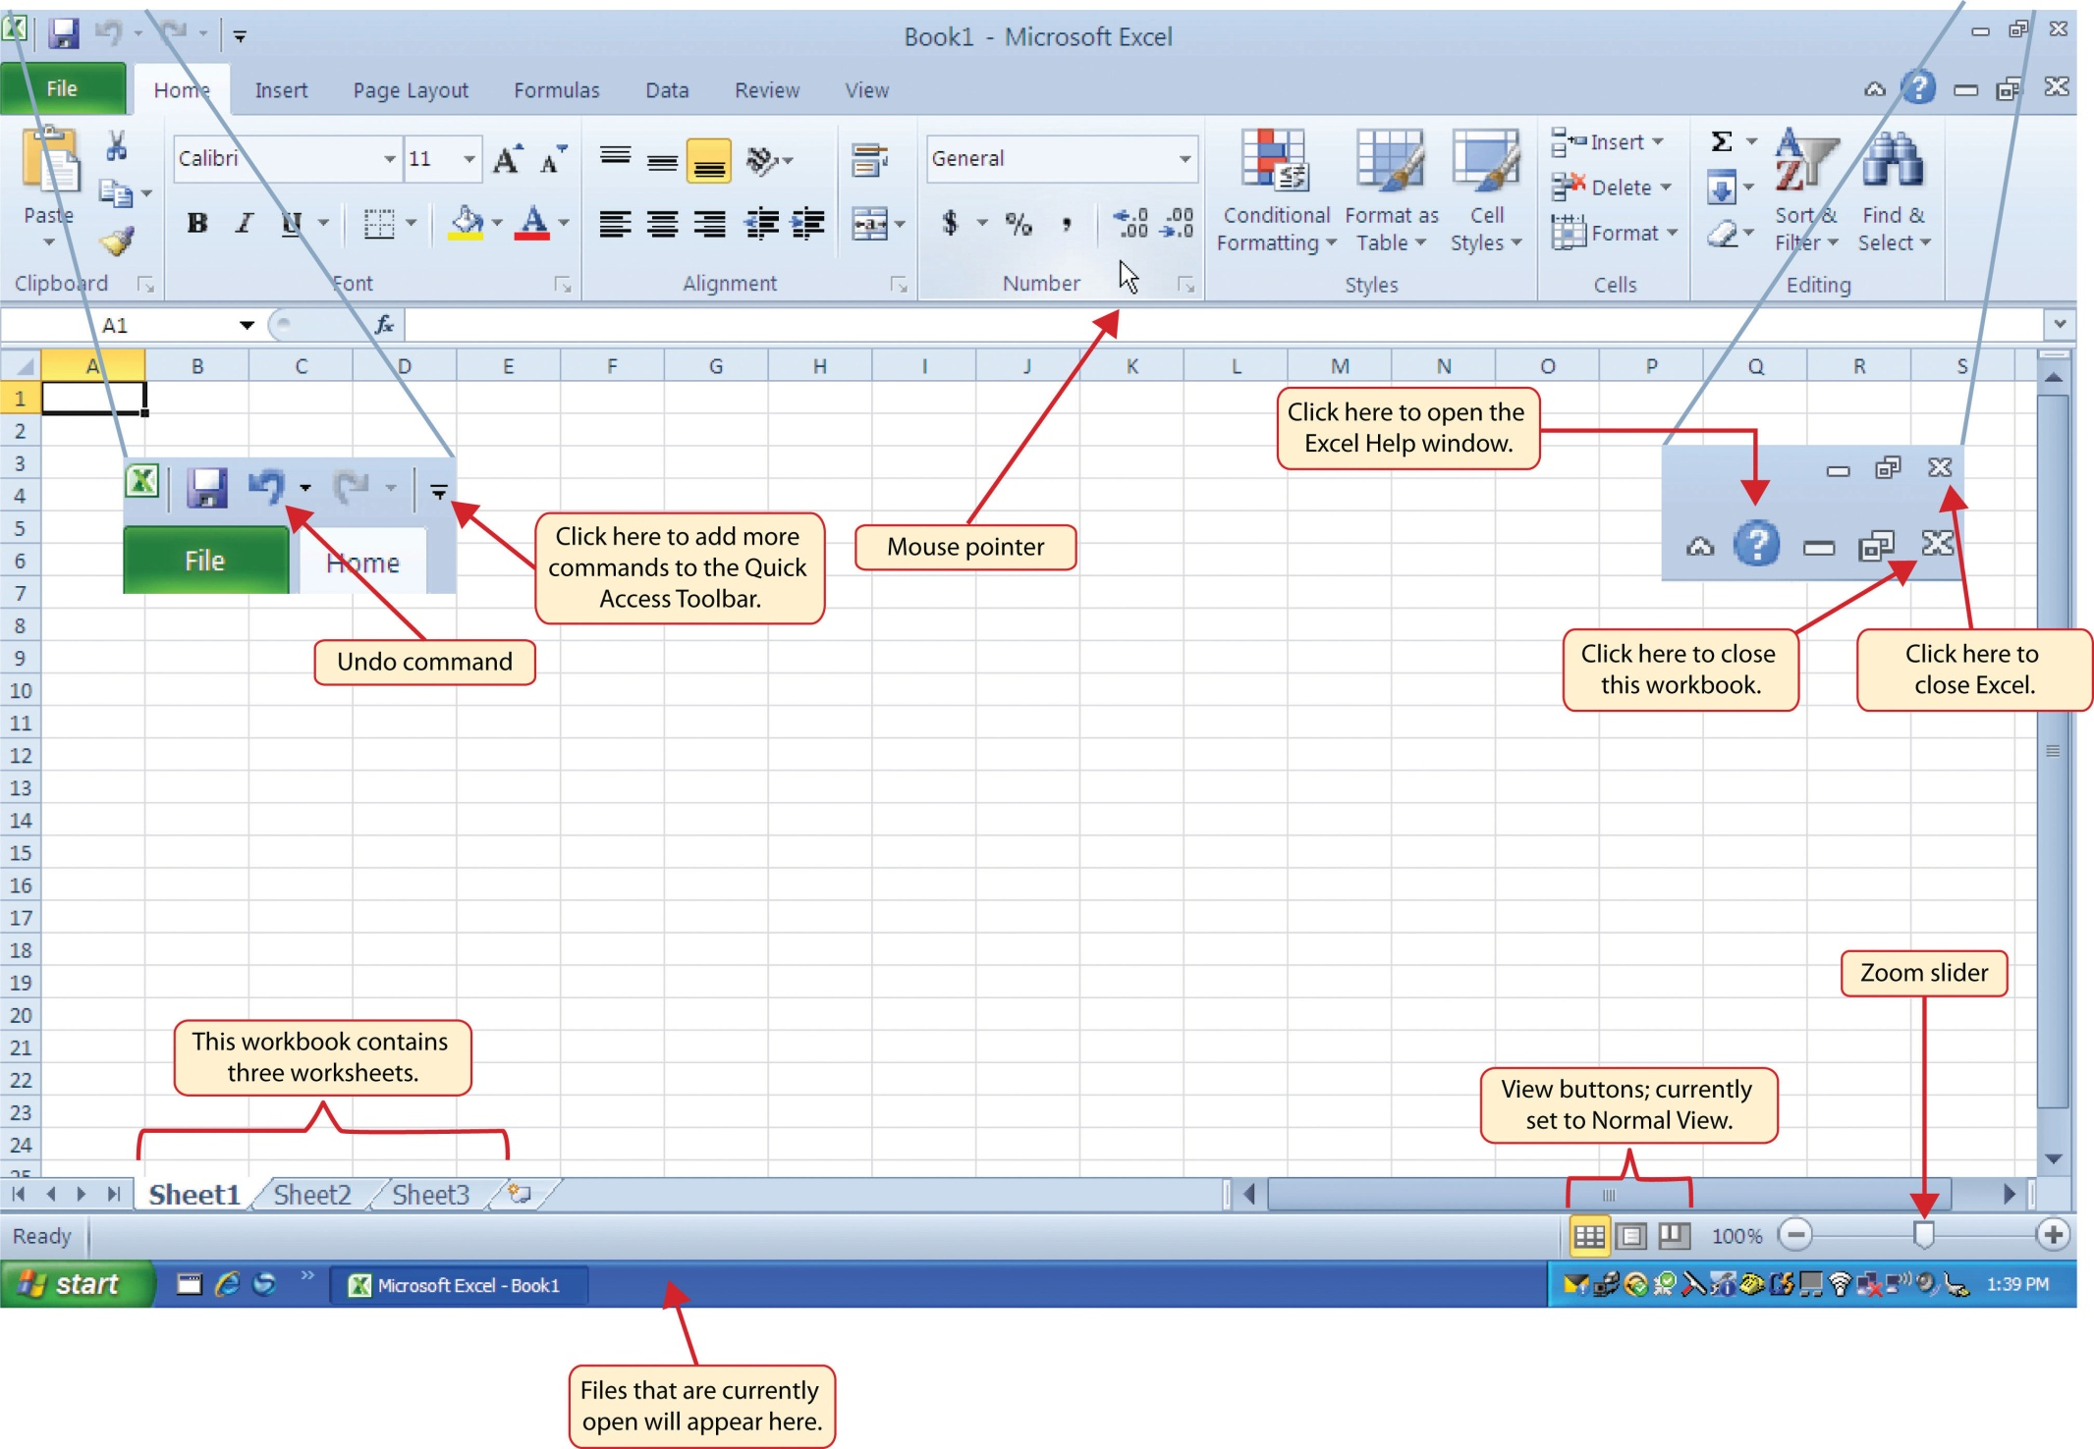

Navigating Worksheets
Data are entered and managed in an Excel worksheet. The worksheet contains several rectangles called cells for entering numeric and nonnumeric data. Each cell in an Excel worksheet contains an address, which is defined by a column letter followed by a row number.

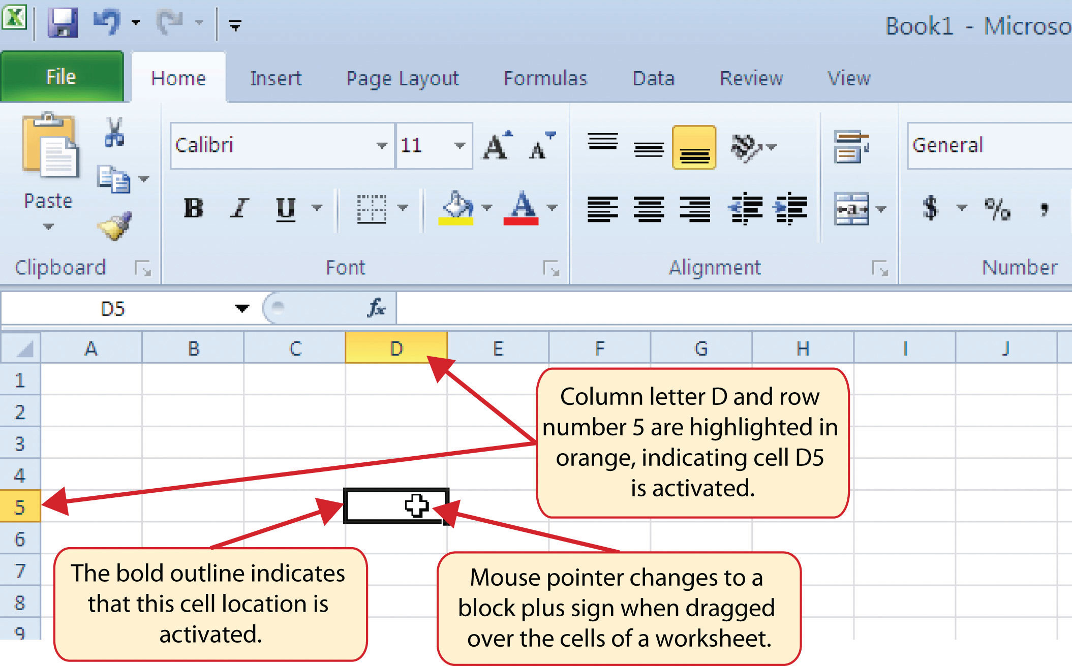

The Excel Ribbon
Excel’s features and commands are found in the Ribbon, which is the upper area of the Excel screen that contains several tabs running across the top. Each tab provides access to a different set of Excel commands.

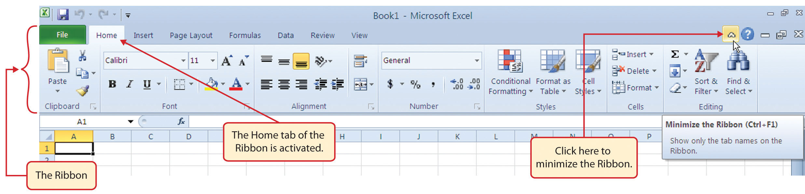

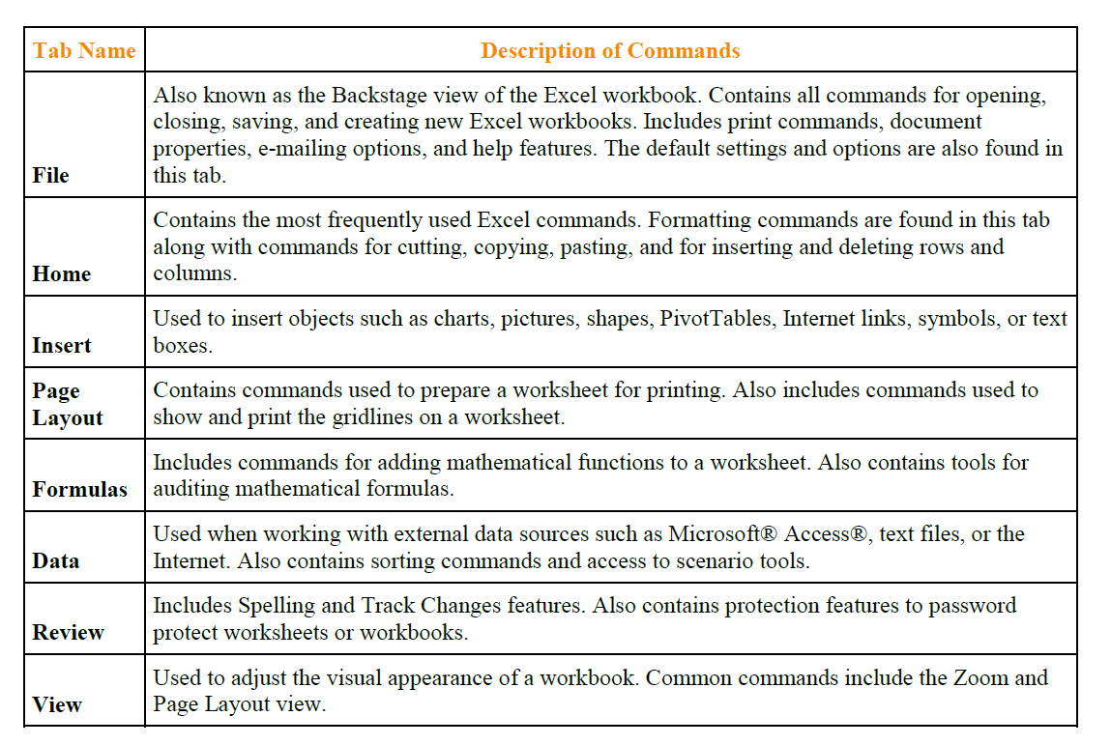

The Right Mouse click
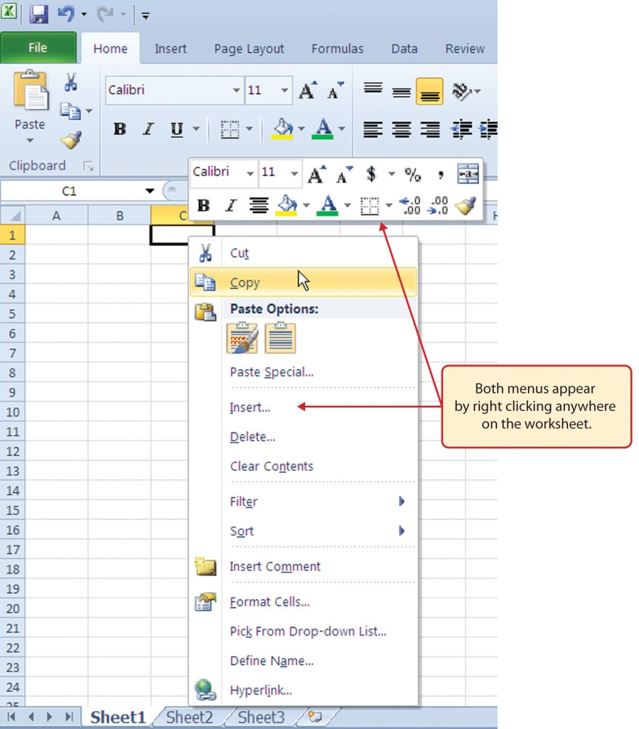
Entering Data
1. Click the desired cell.
2. Type the data into the cell.
3. Press the Enter key to move down a cell.
4. Press the Tab key to move to the next cell to the right.

Autofill
The Auto Fill feature is a valuable tool when manually entering data into a worksheet. This feature has many uses, but it is most beneficial when you are entering data in a defined sequence, such as the numbers 2, 4, 6, 8, and so on, or nonnumeric data such as the days of the week or months of the year

Using Excel’s AutoFill Feature
This can be used to easily copy a formula to a range of cells.
1. Click the desired cell.
2. Place the cursor on the drag fill handle (located at the bottom right corner of the cell).
a. A crosshair will appear.
3. Select the range of cells.

Changing Column Widths and Row Height
By Dragging to Size
1. Move the mouse to the border between two column/row headings, i.e. between column A and B or row 1 and 2.
2. Click and hold the mouse button and drag to the desired width/height.

By Double-Clicking
1. Double-click the border between the two column/row headings and the column will be resized to fit the text in the column.

Inserting Columns
When inserting a column, the new column will be inserted to the left of the selected column.
1. Right-click the desired column heading, click Insert.

Inserting Rows
When inserting a row, the new row will be inserted above the selected row.
1. Right-click the desired row heading.
2. Click Insert.

Moving Data
Select all data to move, grab edge of selection and drag to desired location

Deleting Columns & Rows
Select row or column press delete on keyboard or right mouse click and select delete

Formatting Cells
Format a single cell as desired and use format painter to apply format to other cells

Data Alignment (Wrap Text, Merge Cells, and Center)

Alignment Group in Home Tab
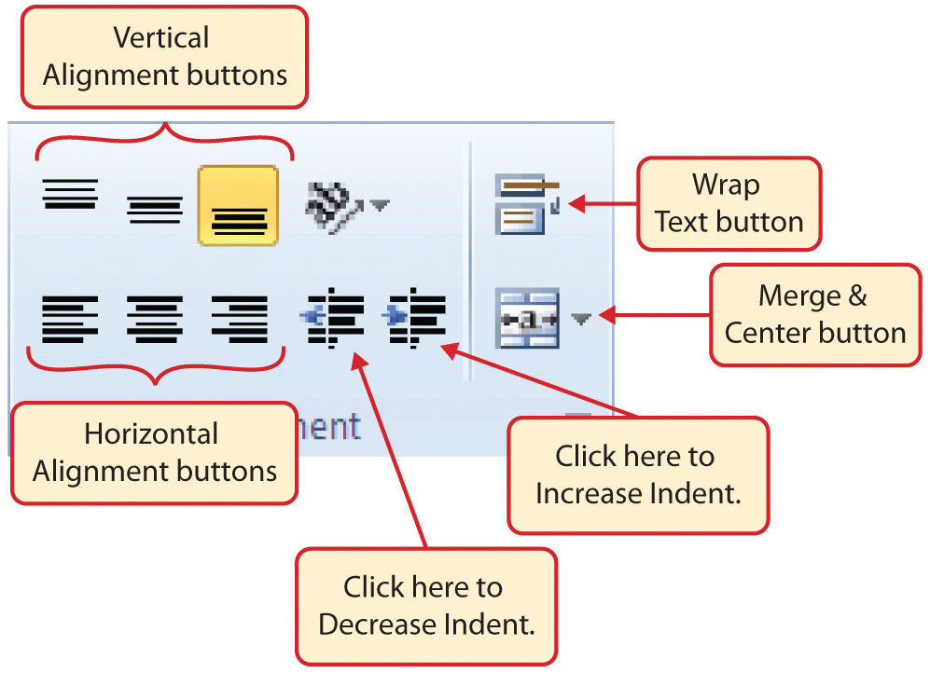

Borders (Adding Lines to a Worksheet)
In Excel, adding custom lines to a worksheet is known as adding borders. Borders are different from the
grid lines that appear on a worksheet and that define the perimeter of the cell locations. The Borders
command lets you add a variety of line styles to a worksheet that can make reading the worksheet much
easier.

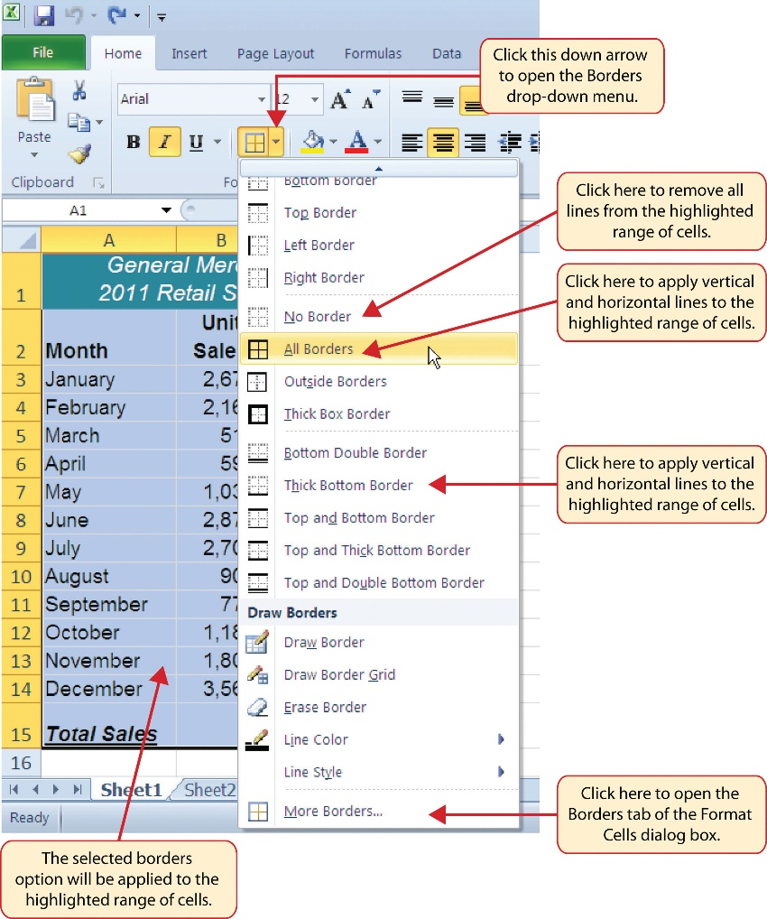
Working with Formulas and Functions

Note: Formulas always start with the equal sign (=).
These are some of the operators that can be used in formulas:
• Addition (+) , example: =A1+A2
• Subtraction (-), example: =A1-A2
• Multiplication (*), example: =A1*A2
• Division (/), example: =A1/A2

Entering a Formula
1. Click the desired cell.
2. To indicate a formula will be in this cell, type (=) followed by the formula.
a. Example: =A1+3
3. Press Enter when finished typing the formula

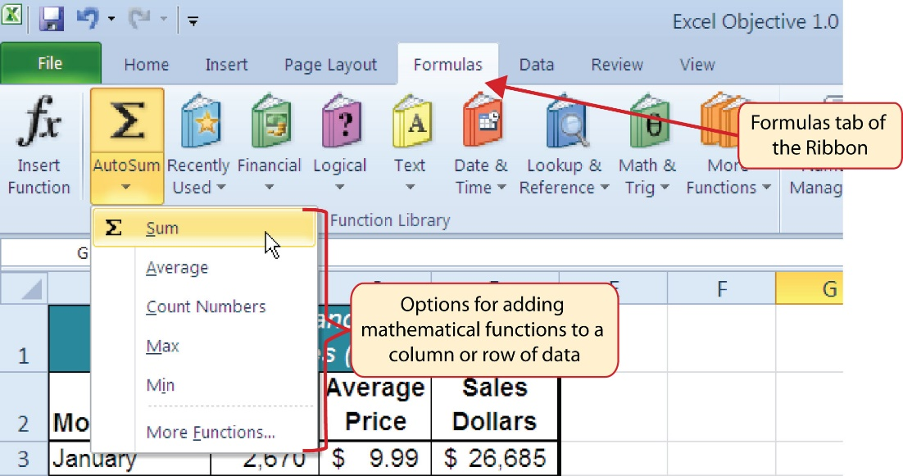

Freezing Panes
Note: When freezing panes, the columns and rows above and to the left of the active cell will be frozen. This means that, no matter if you scroll up and down, or left and right, that row and column will always be visible.
1. Click the desired cell.
2. Click the VIEW tab.
3. In the Window group, click Freeze Panes.
4. Select the desired option.

Sorting Data

Using Filters

