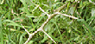 | African Boxthorn  Declared noxious weed | 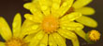 | African Daisy  Declared noxious weed
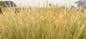 | African Feather Grass  Declared noxious weed | 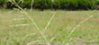 | African Lovegrass  Declared noxious weed
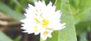 | Alligator Weed  Declared noxious weed  State prohibited | 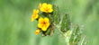 | Amsinckia  Declared noxious weed
 | Angled Onion  Declared noxious weed | 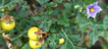 | Apple of Sodom  Declared noxious weed
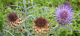 | Artichoke Thistle  Declared noxious weed | 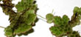 | Azolla
 | Bathurst Burr  Declared noxious weed | 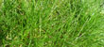 | Bear-skin Fescue  Declared noxious weed  State prohibited
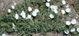 | Bindweed  Declared noxious weed | 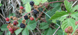 | Blackberry  Declared noxious weed
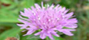 | Black Knapweed  Declared noxious weed  State prohibited | 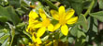 | Boneseed  Declared noxious weed
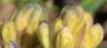 | Branched Broomrape  Declared noxious weed  State prohibited | 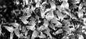 | Bridal Creeper  Declared noxious weed
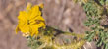 | Buffalo Burr  Declared noxious weed | 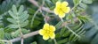 | Caltrop  Declared noxious weed
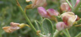 | Camel Thorn  Declared noxious weed  State prohibited |  | Cape Broom / Montpellier Broom  Declared noxious weed
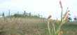 | Cape Tulip (two leaf)  Declared noxious weed | 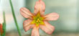 | Cape Tulip (one leaf)  Declared noxious weed
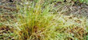 | Chilean Needle Grass  Declared noxious weed | 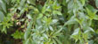 | Chilean cestrum  Declared noxious weed
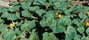 | Devil's Claw (yellow flower)  Declared noxious weed | 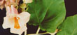 | Devil's Claw (purple flower)  Declared noxious weed
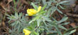 | Flax-leaved Broom  Declared noxious weed | 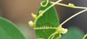 | Dodder  Declared noxious weed
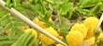 | Giraffe Thorn  Declarednoxious weed  State prohibited | 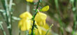 | English Broom  Declarednoxious weed
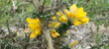 | Gorse  Declarednoxious weed | 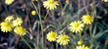 | Fireweed
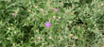 | Hardheads  Declarednoxious weed | 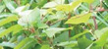 | Giant Knotweed  Declared noxious weed  State prohibited
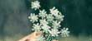 | Hemlock  Declarednoxious weed | 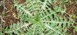 | Golden Thistle  Declared noxious weed
 | Horehound  Declared noxious weed | 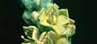 | Great Mullein  Declarednoxious weed
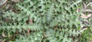 | Illyrian Thistle  Declared noxious weed | 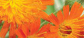 | Hawkweed  Declarednoxious weed  State prohibited
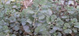 | Ivy-leaf Sida  Declared noxious weed  State prohibited | 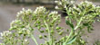 | Hoary Cress  Declared noxious weed
 | Japanese Knotweed Hybrid  Declared noxious weed  State prohibited | 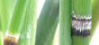 | Horsetails  Declared noxious weed  State prohibited
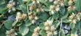 | Khaki Weed  Declared noxious weed |  | Japanese Knotweed  Declared noxious weed  State prohibited
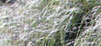 | Lobed Needle Grass  Declared noxious weed  State prohibited |  | Karoo Thorn  Declared noxious weed  State prohibited
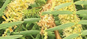 | Mesquite  Declared noxious weed  State prohibited |  | Lagarosiphon  Declared noxious weed  State prohibited
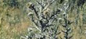 | Nodding Thistle  Declared noxious weed  State prohibited | 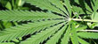 | Marijuana  Declared noxious weed  State prohibited
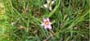 | Onion Grass (Romulea rosea.) |  | Mexican Feather Grass  Declared noxious weed  State prohibited
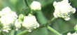 | Parthenium Weed  Declared noxious weed  State prohibited | 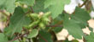 | Noogoora Burr  Declared noxious weed
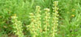 | Perennial Ragweed  Declared noxious weed  State prohibited | 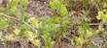 | Pampus Lily-of-the-Valley  Declared noxious weed
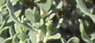 | Poverty Weed  Declared noxious weed  State prohibited | 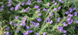 | Paterson's Curse  Declared noxious weed
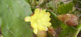 | Prickly Pear (drooping)  Declared noxious weed | 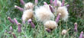 | Perennial Thistle  Declared noxious weed
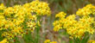 | Ragwort  Declared noxious weed | 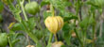 | Prairie Ground Cherry  Declared noxious weed
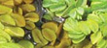 | Salvinia  Declared noxious weed  State prohibited | 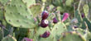 | Prickly Pear (erect)  Declared noxious weed
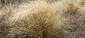 | Serrated Tussock  Declared noxious weed | 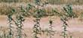 | Saffron Thistle  Declared noxious weed
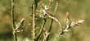 | Slender Thistle  Declared noxious weed | 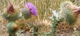 | Scotch Thistle  Declared noxious weed
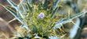 | Soldier Thistle  Declarednoxious weed | 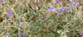 | Silverleaf Nightshade  Declared noxious weed
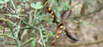 | Spiny Broom  Declared noxious weed | 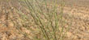 | Skeleton Weed  Declared noxious weed
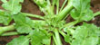 | Spiny Emex  Declared noxious weed | 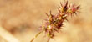 | Spiny Burr Grass  Declared noxious weed
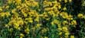 | St John's Wort  Declared noxious weed | 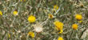 | St Barnaby's Thistle  Declared noxious weed
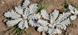 | Stemless Thistle  Declared noxious weed | 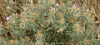 | Star Thistle  Declared noxious weed
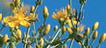 | Tangled Hypericum  Declared noxious weed  State prohibited |  | Sweet Briar  Declared noxious weed
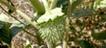 | Thorn Apple (recurved)  Declared noxious weed | 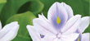 | Water Hyacinth  Declared noxious weed  State prohibited
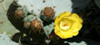 | Wheel Cactus  Declared noxious weed | 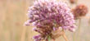 | Wild Garlic  Declared noxious weed
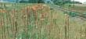 | Wild Watsonia  Declared noxious weed

