Reflective Journal
Date
Site
Location within site
Landowner
Tasks Conducted
Weed Species Present | Erharta longifolia Annual Vedlt Grass  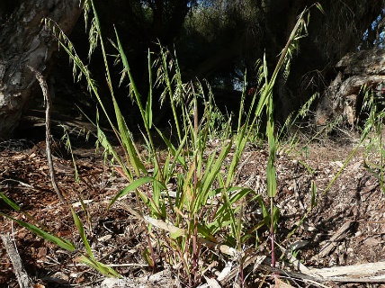
Indigenous Species
EVC’s

Date
Site
Location within site
Landowner
Tasks Conducted
Weed Species Present
Indigenous Species
EVC’s

Date
Site
Location within site
Landowner
Tasks Conducted
Weed Species Present
Indigenous Species
EVC’s

Date
Site
Location within site
Landowner
Tasks Conducted
Weed Species Present
Indigenous Species
EVC’s

