Activity 2.1 Inductions
Describe how you were inducted when you started your job(if not currently employed use a prior job).

Did you receive the following?
□Safety Induction Checklist
□Description of position
□Explanation of work tasks, safe work practices & workplace hazards
□Copies of all OH&S policies, work procedures & checklists
□Explanation of Duty of Care for employer & employees
□PPE required & correct use advice
□Schedule of compulsory training
□Name of supervisor & first aid officer
Activity 2.2 Workplace Expectations
Tick any tasks or expectations that apply to your workplace
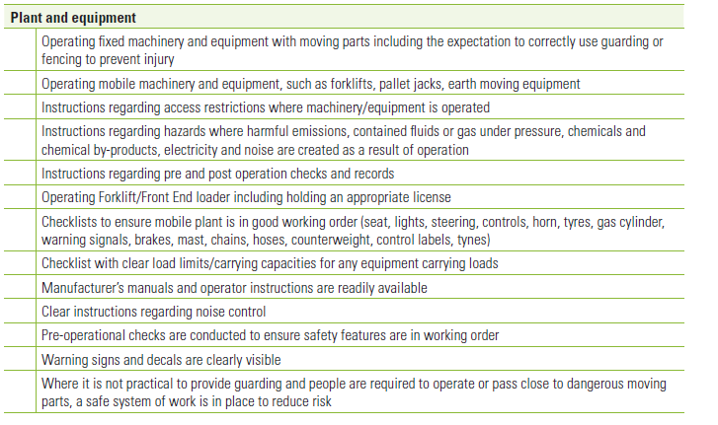
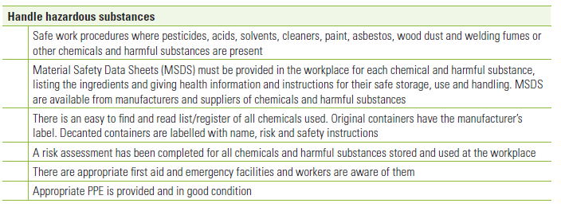
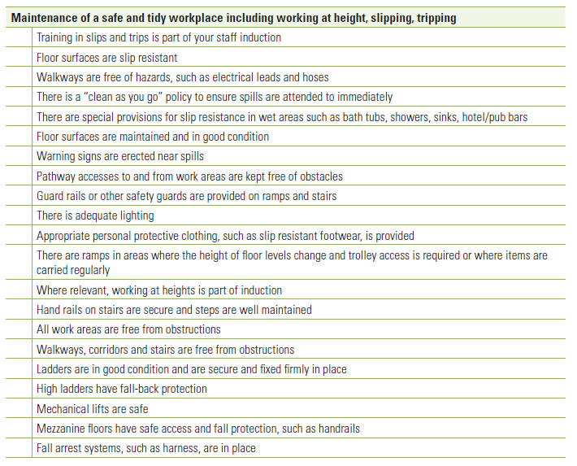
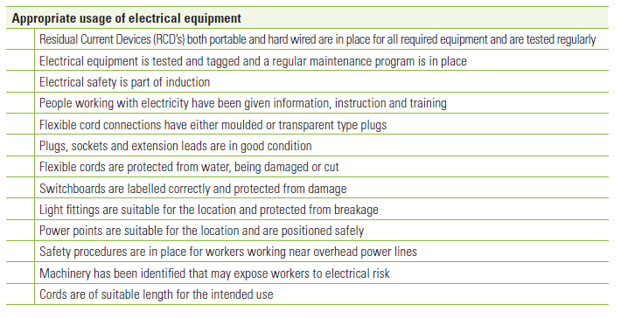
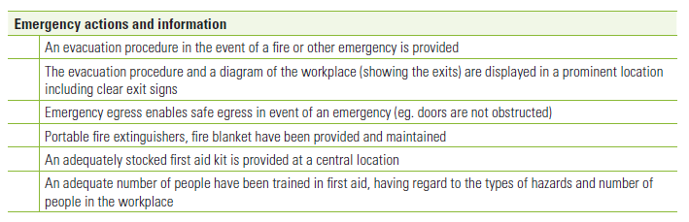
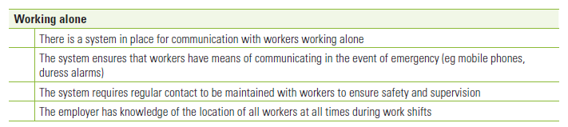
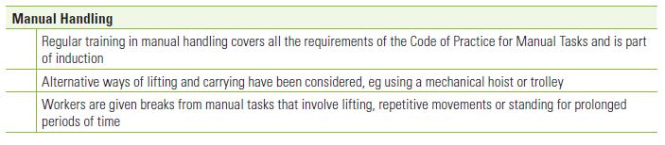
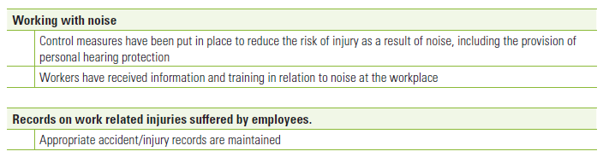

Activity 2.3 Hazard Identification - Chisholm
Take a walk around the campus looking for any OH&S hazards, list below

Activity 2.4 Hazard Identification - Workplace
Identify the tasks that you perform, the hazards and hazard type. Use the list of typical OH&S hazards below
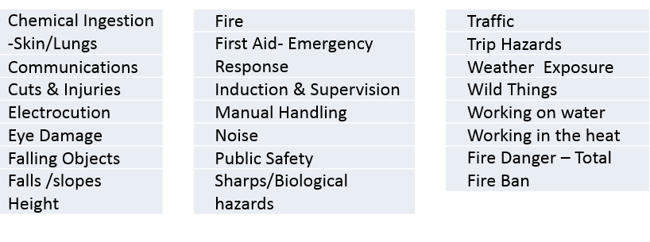
Workplace Task or Activity | Hazard | Hazard Type

Activity 2.5 Risk Assessment & SWMS
Complete the SWMS below using the Risk Analysis Matrix

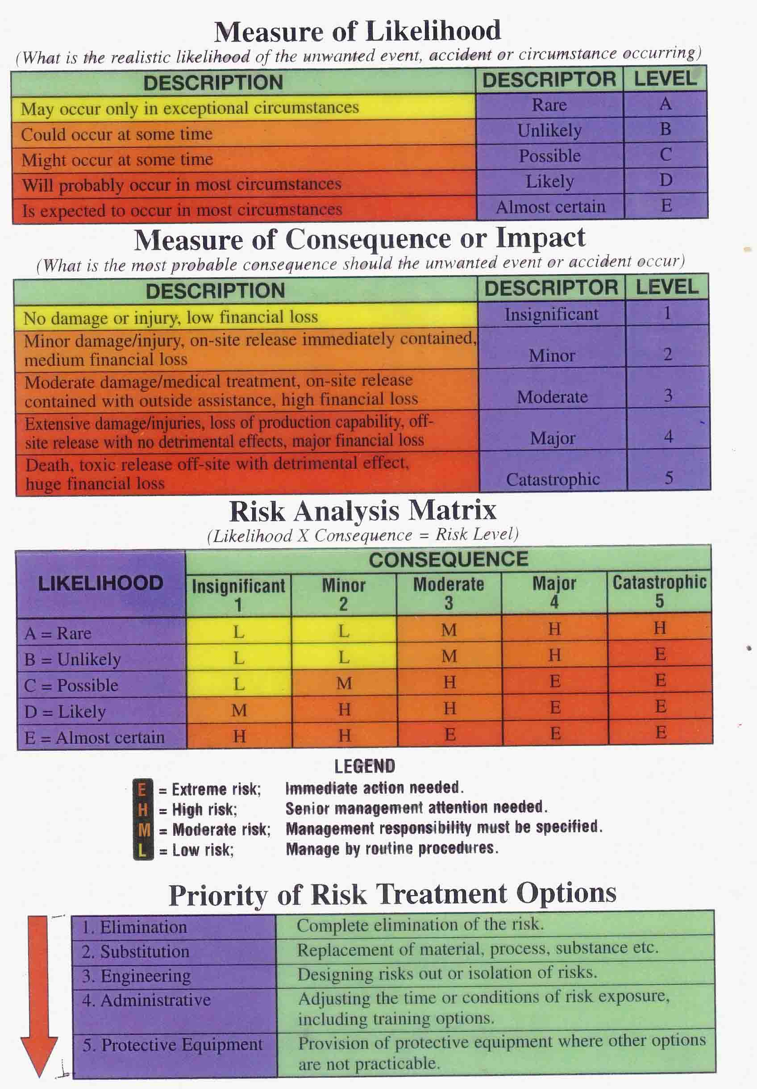

F-2 SEEDS Safe Work Methods Statements (SWMS)
Site Name: |  |  |  |  |  |  |  |  |  | Site Supervisor |  |  |  |  |  | signed
Project: |  |  |  |  |  |  |  |  |  | Date/s
Staff name: |  |  |  |  |  |  |  |  |  |  |  | Activities |  |  |  |  |  |  |  | Site Location/Address for Emergency Purposes
Activity  List the tasks required to perform the activity in the sequence they are carried out. |  |  | Hazards/Risks (See over for a list of Hazards)  Against each task list the hazards that could cause injury or environmental damage |  |  | Likelihood of the unwanted event or circumstance (A-rare to E-almost certain) |  |  | Measure of the Consequence of the event 1 insignificant to 5-Catastrophic |  | Risk Score – Low Moderate High Extreme |  | Risk control measures List the control measures required to eliminate or minimise the risk of injury arising from the identified hazard |  |  |  |  | Who is responsible? to implement the control measure identified |  |  |  | Residual likelihood | Residual Consequence |  |  | Residual Score
Remember: Each SWMS must be site specific and may change during the job.
Activity  List the tasks required to perform the activity in the sequence they are carried out. | Hazards/Risks (See over for a list of Hazards)  Against each task list the hazards that could cause injury or environmental damage | Likelihood of the unwanted event or circumstance (A-rare to E-almost certain) | Measure of the Consequence of the event 1 insignificant to 5-Catastrophic | Risk Score – Low Moderate High Extreme | Risk control measures List the control measures required to eliminate or minimise the risk of injury arising from the identified hazard | Who is responsible? to implement the control measure identified | Residual likelihood | Residual Consequence | Residual Score

All staff / Subcontractors must be inducted in the use of equipment and activities for the job . If staff not inducted then do so before the job commences

OH&S Hazards |  |  |  |  |  | Environmental Hazards
Chemical Ingestion -Skin/Lungs |  | Fire |  | Traffic |  | Chemical Spill Risk
Communications |  | First Aid- Emergency Response |  | Trip Hazards |  | Disease spreading
Cuts & Injuries |  | Induction & Supervision |  | Weather Exposure |  | Erosion Potential
Electrocution |  | Manual Handling |  | Wild Things |  | Habitat destruction
Eye Damage |  | Noise |  | Working on water |  | Off target Spray damage
Falling Objects |  | Public Safety |  | Working in the heat |  | Weed Spread Risk
Falls /slopes Height |  | Sharps/Biological hazards |  | Fire Danger – Total Fire Ban

Activity 2.6 PPE
Each group to choose a task, locate the appropriate PPE in Chisholm store and wear. Then present to class the task and PPE items that are being worn. Explain the hazards that the PPE is protecting the worker from.

