Activity 3.1 Safe Work Procedures
In table groups one person is to induct all others in a Safe Working Procedure, inductees to answer question sheets correctly.

Activity 2.2 Develop a Safe Working Procedure

Activity 3.3 Pre-start Checks
Take a walk to storage shed and look for pre-start and maintenance information for tools, small plant and equipment. List the items you found and pre-start and/or maintenance info. If there is no pre-start or maintenance info list what you think should be done for the equipment
Item | Pre-start info present – describe | Maintenance Info present describe

Activity 3.4 Incident Report Form
Fill out the incident form for an imagery or real workplace incident
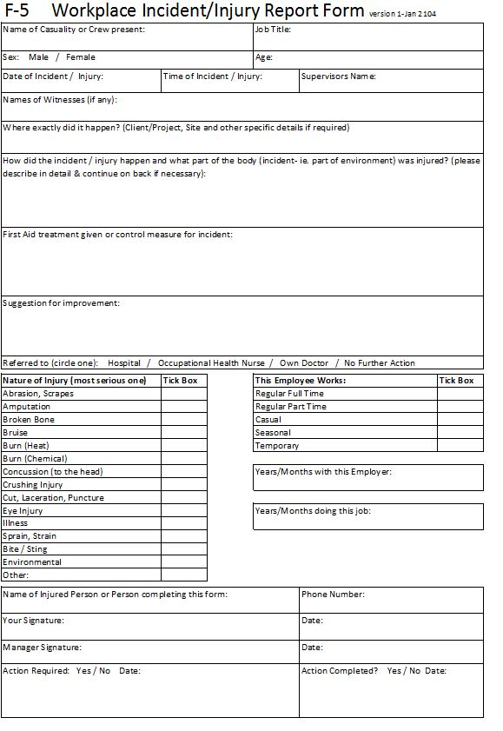
Activity 3.5 Warning Signs
Sign hunt around campus -
Describe the sign | Where is it located? | What is it telling you? | Is the sign a Caution, Mandatory, Dangerous Goods, Fire or Emergency Information Sign?

Activity 3.6 MSDS
Review a MSDS to answer the following
What is the product?

What is it used for?

What are the risks associated with using the product

What are the safety instructions related to using the product in your workplace?

