Activity 3.1 Sustainable Gardening
Visit http://clmstudents.weebly.com/session-3.html
Chose a Sustainable Gardening Module, read it, summarise the key points below and share your findings with class.
Sustainable Gardening Module _______________________________________
Summary of key points

Activity 3.2 Life Cycle Analysis
Chose a product and do a brief Life Cycle Analysis. Firstly think about the life stages the product has. Then, on the following page, think about the impacts of each of these stages

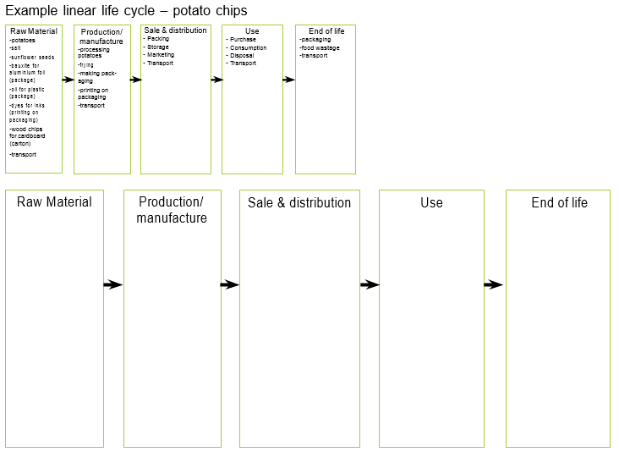

Stage of life cycle | IMPACTS
 | Land & ocean degradation/ habitat destruction | Potentially hazardous material | Energy use | Water use | Greenhouse gas emissions (GHG) | Other emissions | Solid Wastes
Raw materials
Production/ Manufacture
Sale & distribution
Use
End of life

Activity 3.3 Sustainable Actions
Detail an aspect of your workplace that can be improved. Include the following in your response
- What is the environmental sustainability issue?
- How can an improvement be made?
- What are the targets or goals for the improvement?
- What action are required to make it happen?
- How will you monitor success?

