Appendices

Appendix 1: Expertise Level of Assessors
The Vegetation Quality Assessment methodology has been intentionally designed such that assessors do not require highly-specialised expert knowledge of native vegetation. However, an intermediate level working knowledge of native vegetation is required in order to produce some meaningful results and in some cases this will be above the level of some of the existing environmental planner expertise. The following table summarises the minimum level of expertise required to undertake Vegetation Quality Assessments and places it in the context of a range of such skills. Assessors will require reference material (EVC descriptions, benchmarks, mapping etc) and may also require training support in some cases.

 | Environmental Planner | Vegetation Quality Assessor | Specialist Field Botanist
 | - able to recognise native vegetation but seldom required to estimate the number of different native species present | - must be able to estimate (+/- 10%) the number of different native species present | - must be able to distinguish between all the different native species present
recognition of plant species | - preferably able to name dominant native species that are characteristic of EVCs in the region | - must be able to identify native species that are required to discriminate between EVCs in the region | - must be able to name any native species after checking specimens against references
 | - preferably able to routinely access DSE databases on species distribution | - must be able to routinely access DSE databases on species distribution and may be able to add new records | - must be able to routinely access, analyse and contribute to DSE databases on species distribution
 | - preferably able to identify life forms that are characteristic of EVCs in the region | - must be able to identify life forms that are characteristic of EVCs in the region | - must be able to identify any life forms
 | - preferably able to identify ‘high threat’ weed species | - must be able to identify ‘high threat’ weed species and any perennial weed species | - must be able to identify any weed species
recognition of vegetation types | - preferably able to identify the EVCs of the region using reference material | - must be able to identify the EVCs of the region using reference material, and recognise any major floristic community variants that occur within these | - must be able to identify any existing EVCs and FCs (floristic communities) using reference material, and recognise / describe new EVCs/ FCs from appropriate data
recognition of condition attributes | - seldom required to estimate cover values for life forms, weeds, litter, logs etc | - must be able to consistently estimate cover values for life forms, weeds, litter, logs etc | - must be able to consistently estimate, or measure using quantitative techniques, cover values for life forms, weeds, litter etc
recognition of condition attributes | - preferably able to identify recruitment in woody native species | - must be able to identify recruitment in woody native species | - must be able to identify recruitment in any native species
recognition of condition attributes | - preferably able to generally understand changes in condition likely to occur in the medium term (5-10 yrs) either through existing or substantially altered management regimes | - must be able to estimate changes in condition likely to occur in the medium term (5-10 yrs) either through existing or substantially altered management regimes | - must be able to estimate changes in condition likely to occur in the medium term (5-10 yrs) either through existing or substantially altered management regimes, and devise approaches to guide and test such estimates

Appendix 2: Development of the habitat hectares approach and its application in various projects (where known).
Version | Date | Approach / modifications | Projects used
 | August 2001 | Where different from subsequent versions:  - large trees – presence of large trees at ‘site’ (includes areas beyond assessment area)  - large tree health – use 50% threshold to assess health  - understorey – include exotic/weed species within understorey life forms  - understorey – use text to describe thresholds – e.g. ‘majority’, ‘some’, ‘some (but not all)’ etc.  - cover of weeds – refers to ‘serious’ weeds  - regeneration – adequate or inadequate to replace mature plants within life form strata  - organic litter – cover (no qualifiers)  - logs – length (no qualifiers) | - None
v.1.1 | Sept 2001 | As above except:  - understorey – more categories to account for presence / modification of life forms  - understorey – exclude weeds from understorey assessment  - cover of weeds – apply 50% cover threshold for proportion of weed cover due to ‘serious’ weeds  - recruitment (aka. regeneration above) – refine scoring to account for proportion of woody species recruiting adequately | - BushTender 1 – North Central & North East Victoria  - North Central & Mallee CMAs – 10 project areas  - Biodiversity & Farm Business Project – North Central Victoria
v.1.2 | Dec 2002 | As above except:  - large trees – use scale based on number of large trees per hectare in the habitat zone  - tree health – assign three classes of tree health  - tree canopy cover – define as trees reaching 80% of benchmark height  - understorey – convert text to numbers (i.e. % of life forms present and % modified)  - cover of weeds – refer to ‘high threat’ weeds instead of ‘serious’ weeds  - recruitment – qualify score depending on proportion of benchmark woody species present  - organic litter – qualify score depending on cover due to native species  - logs – qualify score depending on proportion of log length with diameter more than half large tree dbh | - Parkes et. al. (2003)  - BushTender 2 – Gippsland  - Northern Victorian Vegetation Condition Modelling project (new data)  - Various CMA projects
v.1.3 | October 2004 | As above except for:  - understorey – life forms with < 10% benchmark cover considered present if any specimens are observed.  - understorey – clarification of understorey shrub modification when overstorey regeneration dominates the life form  - lack of weeds (aka. cover of weeds above) - if total weed cover is negligible (<1%) and high threat weeds are present then score ‘13’  - recruitment – include suppressed canopy species individuals as recruits  - recruitment – treat multiple eucalypt canopy species as one species (apply to both adequacy and diversity of woody species)  - logs – modify score based on presence or absence of large logs (where ‘presence’ of large logs defined as ≥ 25% of benchmark log length)  - logs – cannot be assessed as ‘over-abundant’  - logs – includes cut stumps less than ‘breast height’ (1.3 m tall) but assigned a default length of 0.5 m.  - neighbourhood – adjust for near coastal vegetation.  - treeless vegetation – recruitment assessment involves assessing cover of ‘recruitment area’ (i.e. cumulative cover of bare ground, bryophytes/lichen and soil crust)  - treeless EVC assessment – standardise ‘site condition’ score to make equivalent to treed EVCs. | - Vegetation Quality Assessment Manual

Appendix 3: Vegetation Quality Assessment – Quick Reference Guide
What is being assessed? | Definitions & 1st decisions | Definitions & 2nd decisions
1. Large Trees
Number of large trees/ha (vs EVC benchmark number) and their health in the habitat zone | - Large trees defined by diameter at breast height  (1.3 m above ground) – refer to EVC benchmark  - Determine size (ha) of habitat zone  - Determine number of large trees/ha vs EVC benchmark and place in the appropriate large tree density category | - Health of large trees assessed according to proportion of expected healthy canopy cover that is present (i.e. not missing due to leaf decline, mistletoe infestation)  - Estimate average proportion of expected large tree canopy cover that is present and place in appropriate large tree canopy health class  - Assign large tree score
2. Tree Canopy Cover
Projective foliage cover of tree canopy (vs EVC benchmark cover) and its health in the habitat zone | - Tree canopy cover defined as those trees ≥ 80% of mature height (in EVC benchmark) - can include large trees assessed previously  - Assess projective foliage cover of tree canopy vs EVC benchmark and place in the appropriate tree canopy cover category | - Health of tree canopy assessed according to proportion of expected healthy canopy cover that is present (i.e. not missing due to leaf decline, mistletoe infestation)  - Estimate average proportion of expected tree canopy cover that is present and place in appropriate tree canopy cover health class  - Assign the tree canopy cover score
3. Understorey
Number of understorey life forms present (vs EVC benchmark number) and their modification in the habitat zone | - The IT benchmark number of species is the same as the number canopy species observed  - Life forms with a benchmark cover < 10% must contain at least one specimen within the life form to be considered ‘present’  - Life forms with a benchmark cover ≥ 10% must occupy at least 10% of this benchmark cover for the life form to be considered ‘present’  - Determine number of understorey life forms that are present in comparison to EVC benchmark number and place in the appropriate ‘presence’ category | - Only those life forms considered to be present are assessed for their modification  - For life forms with a benchmark cover of < 10%, then considered substantially ‘modified’ if the life form has < 50% of the benchmark species diversity or no reproductively-mature specimens are observed  - For life forms with a benchmark cover of ≥ 10%, then considered substantially ‘modified’ if the life form has either < 50% of benchmark diversity or < 50% of benchmark cover or occupies at least 50% of the benchmark cover due largely to immature canopy specimens but the cover of reproductively-mature specimens is < 10% of the benchmark cover.  - Determine the proportion of present life forms that are modified and place in the appropriate modification category  - Assign understorey score

What is being assessed? | Definitions & 1st decisions | Definitions & 2nd decisions
4. Lack of Weeds
Cover of weeds in the habitat zone and the proportion of this cover due to ‘high threat’ weed species | - Weeds include all introduced species and other non-indigenous ‘natives’  - Estimate the total projective foliage cover of weeds and place in the appropriate weed cover category | - 'High threat' weed species are defined as those introduced species (including non-indigenous ‘natives’) with the ability to out-compete and substantially reduce one or more indigenous life forms in the longer term assuming on-going current site characteristics and disturbance regime.  - The EVC benchmark lists typical weed species for the EVC in the bioregion and provides an estimate of their ‘invasiveness’ and ‘impact’. In general, those weed species considered to have a high impact are considered high threat regardless of their invasiveness.  - Assess the proportion of the total weed cover due to ‘high threat’ weed species and place in the appropriate threat class  - If total weed cover is negligible (< 1%) and high threat weed species are present then the habitat zone scores ‘13’.  - Assign the lack of weeds score
5. Recruitment
The presence of recruitment and its adequacy in the habitat zone | - Only woody life forms taller than a prostrate shrub are assessed for their recruitment  - Recruitment is assessed for each species, except for multiple eucalypt species which are treated as one species  - Evidence of a recruitment ‘cohort’ is defined as a group of immature woody plants (i.e. no evidence of flowering or fruiting material) that established in a single episode  - If no recruitment is observed then assess whether the EVC is reliant upon episodic disturbance for recruitment to occur (refer to benchmark) and where applicable whether an appropriate episodic recruitment event has occurred within the desirable disturbance period  - Place in the appropriate recruitment class within the ‘No evidence of a recruitment cohort’ category  - If recruitment is observed then go to second decision column. | - Recruitment of the tree canopy is considered adequate when at least 2 cohorts (i.e. group of saplings, group of seedlings) are observed. And, in areas where the current tree canopy cover < benchmark, recruitment is adequate only if there is sufficient recruitment to replace the canopy over time  - Recruitment is considered adequate for an understorey species when the number of observed immature individuals of that species is at least 10% of the number of observed mature individuals  - Determine the proportion of native woody species present that have adequate recruitment and place in the appropriate recruitment class (within the ‘evidence of at least one recruitment cohort’ category)  - Determine the total number of woody species (SS and taller) observed in the habitat zone (both recruiting and non-recruiting) and compare this to number of applicable woody species in the benchmark (treat multiple eucalypt species as one species)  - Determine the woody species diversity and place in the appropriate diversity class  - Assign recruitment score
6. Organic Litter
The cover of ‘native’ organic litter (vs EVC benchmark cover) in the habitat zone | - Organic litter is all fallen dead plant material on the ground detached from the parent plant that is < 10 cm in diameter (includes leaves, twigs and small branches)  - Determine the % cover of organic litter within the habitat zone compared to the benchmark cover and place in the appropriate organic litter cover category | - Determine whether the organic litter cover is dominated by ‘native’ or ‘non-native’ organic litter and place in the appropriate dominance class  - Assign organic litter score
7. Logs
Length of logs/0.1 ha and the presence of ‘large logs’ (vs EVC benchmark length) in the habitat zone | - Logs are any fallen dead plant material detached from the parent plant ≥ 10 cm in diameter (including cut stumps and fallen trees and attached branches)  - A default log length of 0.5 m is applied to cut stumps  - Determine the total length of logs in the habitat zone in comparison to the EVC benchmark and place in the appropriate log length category | - Large logs are defined as ≥ half the diameter of the EVC benchmark large tree dbh  - Large logs are considered present when the large log length ≥ 25% of the EVC benchmark log length  - Determine whether large logs are considered present and place in the appropriate large log class  - Assign logs score
8. Patch Size
Size of patch of which habitat zone forms a part and its degree of disturbance (where applicable) | - The patch includes the habitat zone and any adjoining and contiguous native vegetation regardless of the land tenure, EVC or its condition (also includes adjoining wetlands)  - Estimate the size of the patch and place in the appropriate patch size category | - Native vegetation is considered ‘significantly disturbed’ where it is currently or has historically been subject to activities such as grazing, timber harvesting, roading or fuel reduction burning. Effectively most patches within fragmented or relictual landscapes  - For a patch that is ≥ 20ha, determine if it is ‘significantly disturbed’ and place in the appropriate disturbance class  - Assign patch size score
9. Neighbourhood
Amount of native vegetation within the vicinity of the habitat zone | - The ‘neighbourhood’ includes all native vegetation regardless of land tenure, EVC or its condition (also includes wetlands and rivers/streams)  - Estimate amount of native vegetation within 3 radii of centroid (centre point of habitat zone) – 100 m; 1 km; and 5 km - to nearest 20% and place in the appropriate percentage class  - Multiply the estimated % native vegetation cover by the relevant weighting to calculate the radius values and sum the three scores | - Native vegetation is considered ‘significantly disturbed’ where it is currently or has historically been subject to activities such as grazing, timber harvesting, roading or fuel reduction burning. Effectively most patches within fragmented or relictual landscapes  - Subtract 2 from the summed radii score if > 50% of the neighbourhood within the 5 km radius is 'significantly disturbed'  - Round-off summed scores and assign neighbourhood score  - NB: If the rounded-off value is negative, the final score is adjusted to zero
10. Distance to Core Area
Distance of habitat zone to nearest core area | - A core area is any patch of native vegetation ≥ 50 ha regardless of land tenure, EVC or its condition (also includes wetlands)  - Determine distance from edge of habitat zone to nearest core area and place in the appropriate distance category | - Native vegetation is considered ‘significantly disturbed’ where it is currently or has historically been subject to activities such as grazing, timber harvesting, roading or fuel reduction burning. Effectively most patches within fragmented or relictual landscapes  - Determine whether the core area is ‘significantly disturbed’ and place in the appropriate disturbance class  - Assign core area score

Appendix 4: Proportion of expected healthy cover present

(visual guide for ‘health’ assessment)
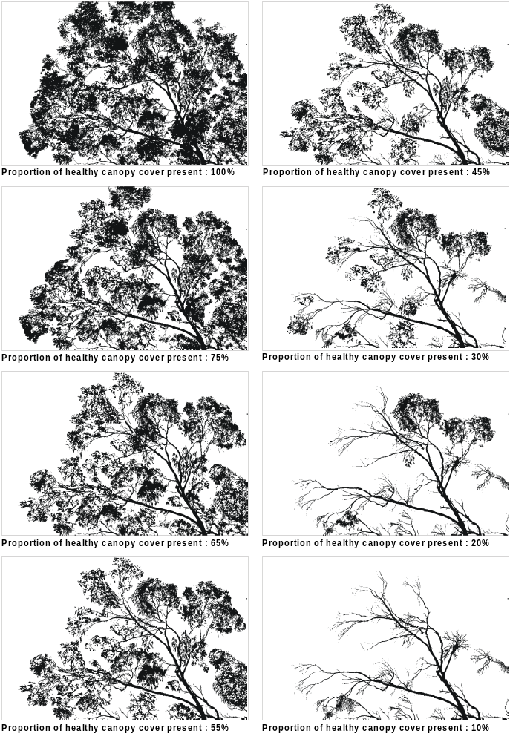

Appendix 5: Canopy projective foliage cover guide

(for canopy trees at various heights and spacings)
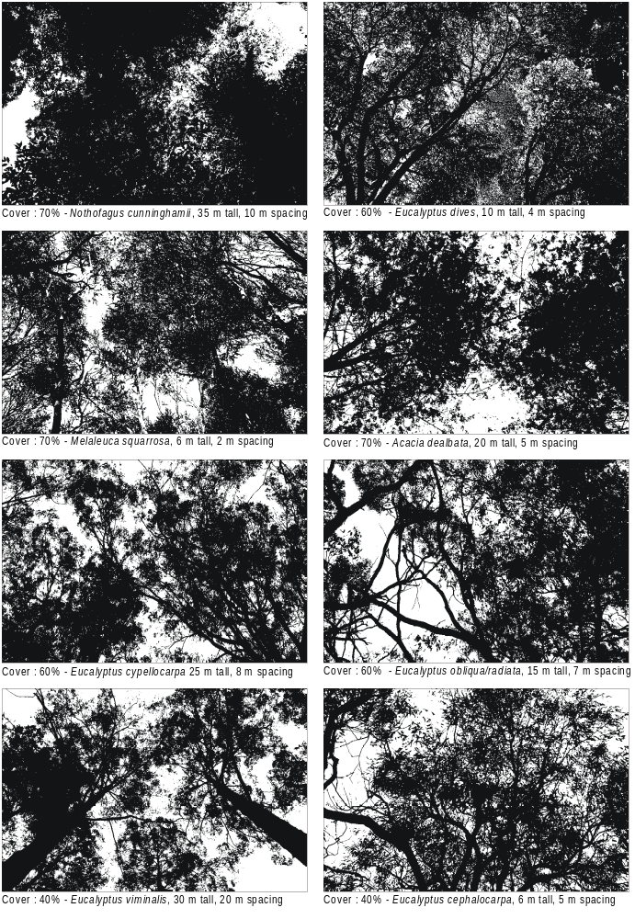Note: The projective foliage cover values have been adjusted to account for the angle of view using the ‘edge of crown’ assessment technique – see Section 7 -Tree Canopy Cover. The difference between the ‘angle of view’ and projective foliage cover values is greatest when the canopy height is lowest.

Appendix 5: Canopy projective foliage cover guide

(for canopy trees at various heights and spacings)
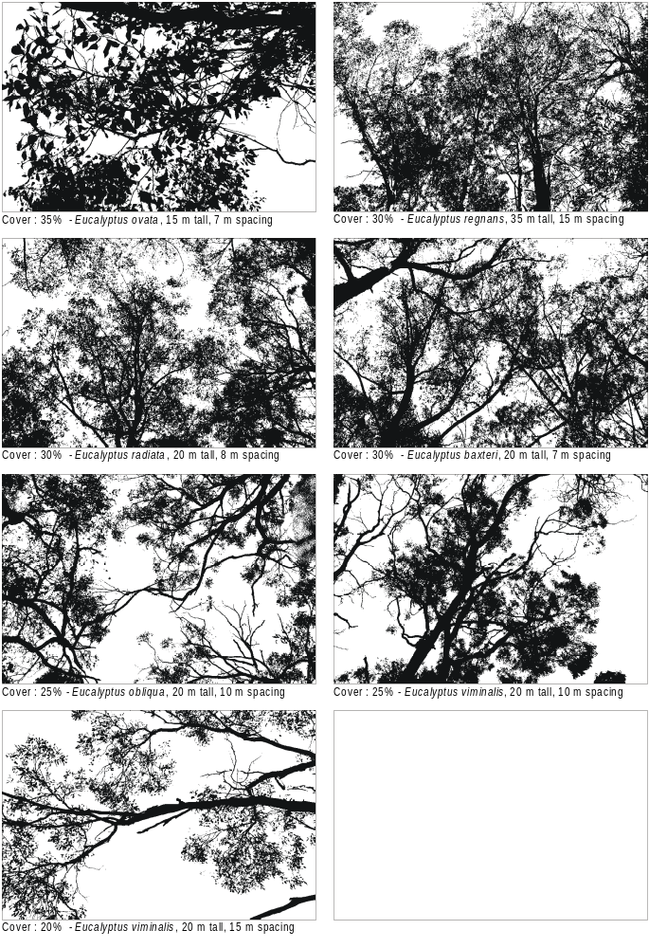Note: The projective foliage cover values have been adjusted to account for the angle of view using the ‘edge of crown’ assessment technique – see Section 7 -Tree Canopy Cover. The difference between the ‘angle of view’ and projective foliage cover values is greatest when the canopy height is lowest.

Appendix 6: Understorey life form categories applied in vegetation quality assessments
Life form | Life form code | Definitions
Immature Tree | IT | Woody plants (consisting of the tree canopy species) greater than 5 m in height but less than 80% of the mature canopy height (refer to EVC Benchmark description).
Tree (sub-canopy) or Large Shrub | T | Woody plants greater than 5 m in height, with single stems that never form part of the tree canopy.
Mallee Tree  (sub-canopy) | MT | Woody mallee-type plants greater than 3 m in height with multiple stems that never form part of the tree canopy.
Medium Shrub | MS | Woody plants between 1 m and 5 m in height.
Small Shrub | SS | More or less erect, woody plants that are between 20 cm and 1 m in height.
Prostrate Shrub | PS | Woody plants with stems and branches that often trail along the ground and do not exceed 20 cm in height.
Large Herb | LH | More or less erect, non-woody plants with non-grassy leaves, greater than  50 cm tall.
Medium Herb | MH | More or less erect, non-woody plants with non-grassy leaves, between 5 cm and 50 cm tall.
Small or  Prostrate Herb | SH | More or less erect, non-woody plants with non-grassy leaves, less than 5 cm in height. Many of this group are ephemerals (ie. germinate, reproduce and die within a few weeks). The group includes prostrate and carpet-forming herbs.
Large Tufted Graminoid | LTG | A robust grass, sedge, rush or similar, usually with more than one flower stalk. Usually large numbers of leaves arising from a common, often broad base or clump, more than 1m tall. Includes trunked Xanthorrhoea spp and palm-like sedges, such as Gahnia clarkei.
Medium to Small Tufted Graminoid | MTG | A grass, sedge, rush or similar, usually with more than one flower stalk. Usually large numbers of leaves arising from a common base or clump, between 10 cm and 1 m tall.
Tiny Tufted Graminoid | TTG | A grass, sedge, rush or similar, usually with more than one flower stalk. Usually a number of leaves arising from a common base or clump, less than 10 cm in height.
Large Non-tufted Graminoid | LNG | A robust grass or sedge, with leaves arranged along single, erect flower stalks, which in turn arise from rhizomes or stolons (creeping above or below ground stems), more than 1 m tall.
Medium to Tiny Non-tufted Graminoid | MNG | A grass, sedge, rush or similar with leaves arranged along single, erect flower stalks, which in turn arise from rhizomes or stolons (creeping above or below ground stems), not exceeding 1 m tall. Also includes plants with a few grass-like leaves arising from a common base (e.g. some lilies, orchids).
Hummock Grass | HG | A grass of semi-arid and arid environments that grows from a central point to form a distinctive ring over time (particular to Triodia species in Victoria).
Ground Fern | GF | A fern-like non-flowering plant, usually with several to many fronds (ie. deeply divided into leaflets or segments) arising from a common base. Usually growing less than 1 m.
Tree Fern / Palm | TF | A large tree-like fern or palm, with a distinct, fibrous or scaly trunk (made up of the persistent leaf bases) and a crown of very large divided fronds or leaves.
Epiphyte | EP | A plant that grows entirely upon other plants (root system not immersed in the soil or water). Includes aerial parasites, such as mistletoes but not dodder laurels (included under scrambler or climber).
Scrambler or Climber | SC | Woody or non-woody plants that rely upon other plants (dead or alive) or other structures (rocks or logs) for support. The main difference between this category and plants described as 'prostrate', is the habit of using other plants to lean on or climb. Species in this group may form dense colonies.
Bryophytes and Lichens | BL | A broad grouping of non-vascular terrestrial plants. Differentiated from soil crust below by its vertical structure.
Soil Crust | S/C | A hard ‘crust-like’ layer formed on the soil surface by a combination of algae / crustose cryptogamic life forms and soil particles. Often contains no vertical structure.

